**2013/14 Equality & Diversity Information Report**

University of Cambridge

Equality@admin.cam.ac.uk

Published 31 January 2015



Table of Contents

1.0 Foreword 4

2.0 Introduction 5

3.0 Staff 6

3.1 Key facts and figures 6

3.2 Gender 6

3.2.1 Groups and initiatives 7

3.2.2 Staff groups and grades 9

3.2.3 Academic staff type 9

3.2.4 Employment status 10

3.2.5 STEMM vs AHSS 10

3.2.6 Senior University Committees 11

3.2.7 Equal Pay Reviews 12

3.3 Ethnicity and Nationality 12

3.3.1 Groups and Initiatives 12

3.3.2 Ethnic Groups 13

3.3.3 Nationality 14

3.3.4 Staff groups and grades 14

3.3.5 Employment status 15

3.4 Disability 16

3.4.1 Groups and initiatives 16

3.4.2 Staff groups and grades 17

3.5 Age 18

3.6 Other Equality Areas 18

3.6.1 Sexual Orientation and Gender reassignment 19

3.6.2 Religion or Belief 19

5.0 Equality Analysis- Equality Assurance Assessments 26

Appendix 1 27

Staff - Definitions and notes 27

Age (staff) 27

Disability (staff) 28

Ethnicity (staff) 28

Science, Technology, Engineering, Mathematics and Medicine Departments (STEMM) 28

Staff at the University of Cambridge 28

Benchmarking 29

Students - Definitions and notes 29

Appendix 2 – Letter to Times Higher Education 30

Promoting gender balance 30

Appendix 3 32

Figure 1: Equality and Diversity Infrastructure 5

Figure 2: Headcount summary - Red=staff group, Blue=ethnicity, Green=gender 6

Figure 3: Russell Group gender balance 7

Figure 4: Anna Watkins (top), Alison Saunders (bottom) 8

Figure 5: WiSETi lecture - Molly Stevens 8

Figure 6: Gender breakdown by grade 9

Figure 7: Gender breakdown of academic staff 10

Figure 8: Employment status by gender 10

Figure 9: Overall STEMM vs AHSS as well as academics by gender 11

Figure 10: Pyramid of Power 12

Figure 11: BME, White - Other, White - British pie chart 14

Figure 12: Nationality pie chart 14

Figure 13: Staff groups by ethnicity and nationality 15

Figure 14: Staff grades by ethnicity and nationality 15

Figure 15: Employment status by ethnicity 16

Figure 16: Disability lecture - Rachel Perkins 16

Figure 17: Disability disclosure rate by grade 17

Figure 18: Age by gender 18

# 1.0 Foreword

This report presents equality and diversity information for the academic year 2013/14 at the University of Cambridge. It also highlights some of our many activities and initiatives which are informed by the University’s 2012 Equality Objectives with a view to enhancing the experience of University members with protected characteristics.

A focus on women this year saw a dozen events aimed directly at the discussion of gender equality. The launch of book project *The Meaning of Success*[1] brought together staff from across the University to nominate women in all staff groups whom they felt to be successful. This initiated a continuing discussion about how to redefine success in academia. Active participation in the Athena SWAN programme has seen an additional seven departments receive an award, most notably the first ever Gold award for a Physics Department. The University received an institutional Silver Award, one of only five in the country. University of Cambridge departments now hold one Gold award, one Silver award and 11 Bronze awards covering 84% of STEMM staff (77% STEMM Departments).

The Equality and Diversity Section has worked with University diversity networks, student groups and the local community to provide resources to the University and the community as a whole. In addition to the events on gender, the 2013/14 calendar included the Annual Race Lecture by renowned human rights solicitor Imran Khan; a theatre production for the International Day for Persons with Disabilities; an LGBT panel; a women in faith discussion; a talk on implicit bias as well as the People Matter Week 7-day series of events geared toward wellbeing. These events create a space for discussion and awareness as well as enjoyment of the vast amount of diversity at the University. The 2013/14 academic year saw the organisation of more than 20 equality-related events inviting more than 3,500 bookings.

The University continues to strive for excellence and the 2013/14 equality and diversity year has demonstrated the outstanding commitment of the teams and individuals involved. We begin the new Academic Year by thanking Professor Dame Athene Donald, the retiring and first Gender Equality Champion, for her untiring work on gender in the workplace locally, nationally and internationally. We welcome a set of new Champions[2] who will build on her work at University and School level.

**PROFESSOR JEREMY SANDERS CBE FRS**

**Pro-Vice-Chancellor for Institutional Affairs**

**Chair of Equality & Diversity Committee and Athena SWAN Governance Panel**

# 2.0 Introduction

The University produces and publishes this report by the 31st January each year in accordance with the Equality Act 2010 (Specific Duties). It is committed to engaging all of its members in promoting a positive and fully inclusive work and study environment. In aiming to be a fair and non-discriminatory environment in line with the equality legal duties which apply to the higher education sector, it has committed to its own Equality Objectives[3] which are continually monitored.

There are several bodies across the University representing equality and diversity. Figure 1 shows the structure of these committees which develop and implement appropriate policy, recommend the provision of training and provide senior engagement in all diversity strands. The Equality and Diversity (E&D) Committee along with the Gender Equality Group (GEG) monitor Key Performance Indicators (KPIs) in the Equality Objectives across the University.

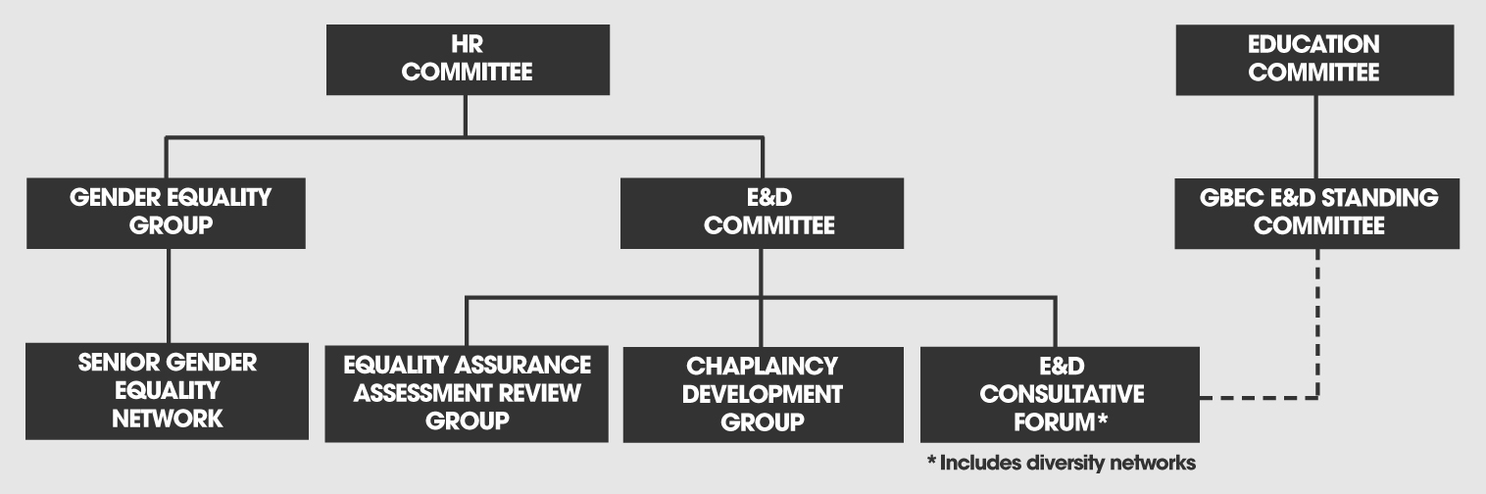

Figure : Equality and Diversity Infrastructure

A new online learning tool, E&D Essentials[4], designed in-house specifically for the academic environment, was launched in October 2013 and is now a required part of induction for all new employees and for anyone on an appointment committee. Monitoring on general uptake is regularly undertaken and reported to appropriate departments and committees.

Please see notes and definitions in Appendix 1 for a detailed explanation of the data.

# 3.0 Staff

## **3.1 Key facts and figures**

On the 31 July 2014, the University was comprised of 10,735 employees in four University staff groups (Table 1).

Table : Count by staff group

|  |  |  |
| --- | --- | --- |
| **Staff Group** | **Number of employees (headcount)** | **Percentage of employees** |
| Academic | 1,720 | 16.0% |
| Academic-Related | 1,707 | 15.9% |
| Assistant | 3,572 | 33.3% |
| Researcher | 3,736 | 34.8% |

* The gender breakdown in the University is 49.2% (5,278) female and 50.8% (5,457) male.
* Of employees with a known disclosed ethnic background (77%), staff ethnicity breaks down as 11.0% Black and Minority Ethnic (BME), 27.6% White - Other and 61.4% White - British.
* 14.6% (1574) of University employees responded to the question on disability
* 2.7% (294) of all employees disclosed having a disability. Of respondents to the question, 18.7% disclosed a disability[5].

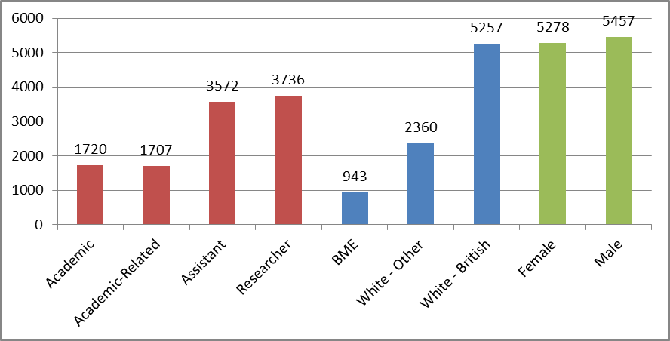

Figure : Headcount summary - Red=staff group, Blue=ethnicity, Green=gender

The University’s new online recruitment system enables more comprehensive collection of diversity information through the Employee Self Service system (ESS)[6] for staff. It is anticipated that this will increase voluntary disclosure rates for personal information.

## **3.2 Gender**

The University has particularly invested in gender initiatives this year. The launch of the book project *The Meaning of Success* which sought submissions of stories of successful women from the whole University reached an international audience, with over 40,000 page views to the website in the first month after launch. The book complemented a letter (Appendix 2) sent to the Times Higher Education which was signed by more than 50 members of staff including heads of colleges and departments. The letter called on the sector to improve procedures so that women have a better chance of progressing to senior positions in academia.

The receipt of an Athena SWAN Silver Institution Award in 2014 is further recognition of the work that the University has put into developing opportunities and progressing equality for women.

With a population that is 49.2% (5,278) female and 50.8% (5,457) male staff members, this compares to a Russell Group Universities average of 52% female staff (Figure 3).

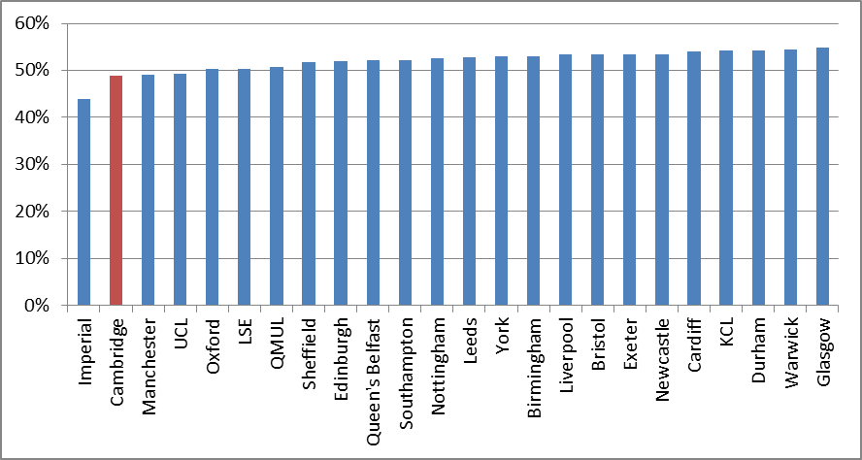

Figure : Russell Group gender balance

In focusing attention on the gender balance, the University works closely through several groups, organisations and initiatives to maintain its gender focus.

### 3.2.1 Groups and initiatives

Gender Action Plan (GAP)[7]

The GAP brings together all of the University’s gender initiatives and provides a road map for the different University bodies to follow the progress being made.

Women’s Staff Network (WSN)[8]

The WSN focuses on progressing the University’s gender objectives by directly engaging with staff to enable women to inform governance and University policy. There was a very successful release of a WSN bulletin discussing some of the initiatives for the year which included events such as the launch of *The Meaning of Success* for International Women’s Day 2014, Making Your Voice Heard, Aurora - women in Leadership programme and the New Perspectives series.

Senior Gender Equality Network (SGEN)[9] 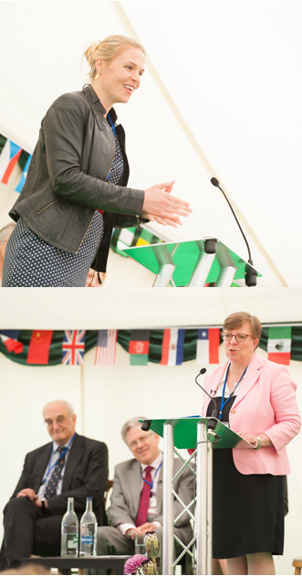

Figure : Anna Watkins (top), Alison Saunders (bottom)

SGEN members are senior members of the University who seek to progress actions in the GAP by sharing best practice, advising departments and tracking progress. On 19th June 2014, the SGEN hosted “The Impact of Gender” with Olympic Gold medallist, Anna Watkins MBE and Alison Saunders CB, Director of Public Prosecutions (Figure 4); this high profile event had over 180 attendees.

Gender Equality Group (GEG)[10]

GEG was founded in 2010 as a permanent University committee to make recommendations on how to improve gender equality at the University. It is chaired by the Gender Equality Champion and reports directly to the HR committee. Some of GEG’s initiatives have included improving the environment for parents and carers, equal pay, mentoring and improving progression rates for women.

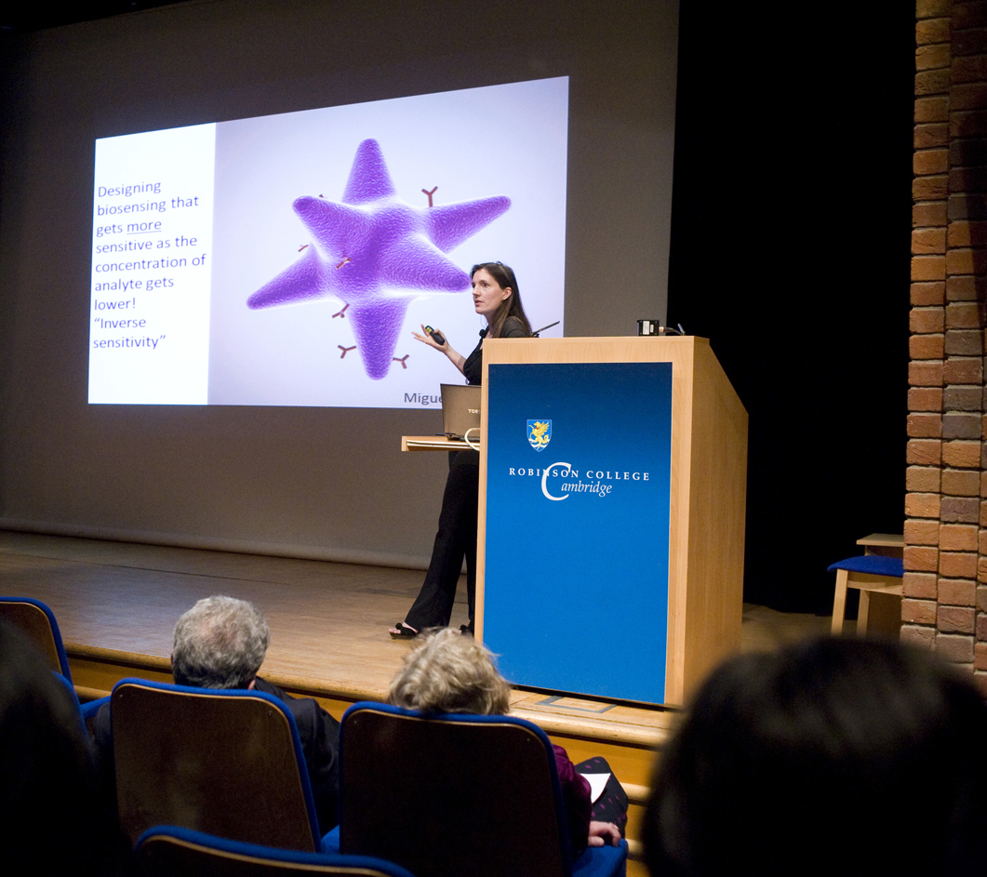Women in Science, Engineering, Technology initiative (WiSETi)[11] and Athena SWAN[12]

Figure : WiSETi lecture - Molly Stevens

WiSETi is a University initiative which was introduced in 1999. WiSETi created the Senior Academic Promotions (SAP) CV Scheme, which was initially for women in STEMM (Science, Technology, Engineering, Mathematics and Medicine) subjects but has now been extended across the University (47 mentees with 18 mentors participated in 2013). WiSETi also hosts an annual lecture featuring a prominent female scientist engaged in a research career (Figure 5). The WiSETi Project Officer is the primary contact for the Athena SWAN Charter[13] at the University. The University was awarded a Silver Institution Award this year joining only 4 other institutions nationally with the accolade. 13 University departments now hold an Athena SWAN award, including a Silver award for the School of Clinical Medicine and a Gold award for the Department of Physics, which was awarded in 2014.

Gender Equality Champion(s)

The Gender Equality Champion is the chair of GEG and a representative for gender throughout the University. This role will be expanded to two Gender Equality Champions for 2014/15, with one representing STEMM subjects and the other AHSS (Arts, Humanities and Social Sciences) subjects. The Champion programme will be further expanded to include the Schools with the identification of SGEN Champions.[14].

### 3.2.2 Staff groups and grades

One of the aims of creating SGEN was to address the under-representation of women in senior roles. The representation of the percentage of female employees in each grade increases from 56.1% at Grade 1 up to 71.7% at Grade 4 and then decreases through the remaining grades to 16.8% at the Grade 12 (Figure 6).

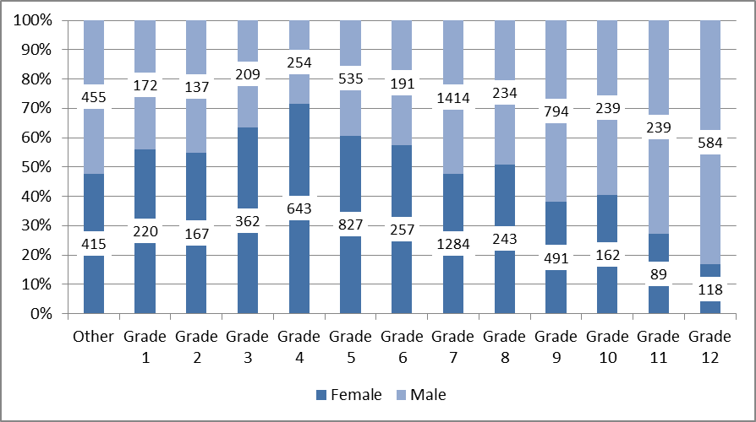

Figure : Gender breakdown by grade

The high percentage of female employees at Grade 4 corresponds with the high percentage of Assistant staff who are female (61.7%). Overall, Assistant staff comprise a third of the University staff population (33.3%).

### 3.2.3 Academic staff type

The representation of female staff amongst Academics is 28.0%. They represent 34.8% of University lecturers and 34.7% of Senior lecturers. 16.1% of professors are female (Figure 7) which breaks down as 13.9% in STEMM and 21.7% in AHSS. This compares with 20% across the Russell Group of Universities in 2012/13.

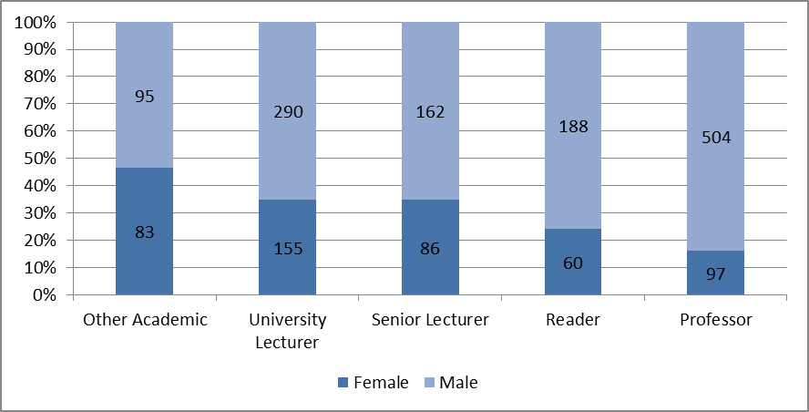

Figure : Gender breakdown of Academic staff

### 3.2.4 Employment status

Fixed term contracts make up 26.0% of all contracts at the University. 24.4% of female staff are on a fixed term contract compared to their male counterparts for whom 27.5% of contracts are fixed term. Overall, 20% of all employees are part-time, with female employees at 29.3% compared to 11.0% of male employees.

93.0% of male Academics are on established contracts with 82.7% of female Academics on established contracts (Figure 8).

Figure : Employment status by gender

### 3.2.5 STEMM vs AHSS

Female staff comprise 45.4% and 53.5% of all STEMM and AHSS staff respectively (Figure 9). Female Academics in STEMM and AHSS comprise 20.0% and 39% of Academic staff respectively.

Figure : Overall STEMM vs AHSS as well as Academics by gender

### 3.2.6 Senior University Committees

Senior University Committees have a total of 158 occupied positions; several roles are taken up by the same person or are currently vacant. 27.9% (44) of members are female staff. Female staff make up 41.6% of the Council, which is the largest committee. Figure 10 demonstrates the gender breakdown across the senior administration of the University.

Table : % Female

|  |  |
| --- | --- |
| **Senior Committees** | |
| Audit Committee | 30.0% |
| Board of Scrutiny | 33.3% |
| Council | 41.7% |
| Finance Committee | 25.0% |
| General Board of the Faculties | 14.3% |
| Planning and Resources Committee | 33.3% |
| Resource Management Committee | 20.0% |
| **Councils of Schools** | |
| Arts and Humanities | 23.1% |
| Biological Sciences | 20.0% |
| Clinical Medicine | 35.7% |
| Humanities and Social Sciences | 11.1% |
| Human Resources Committee | 44.4% |
| Physical Sciences | 20.0% |
| Technology | 23.1% |
| Note: May include any of appointed members, elected members and ex officio members | |
|

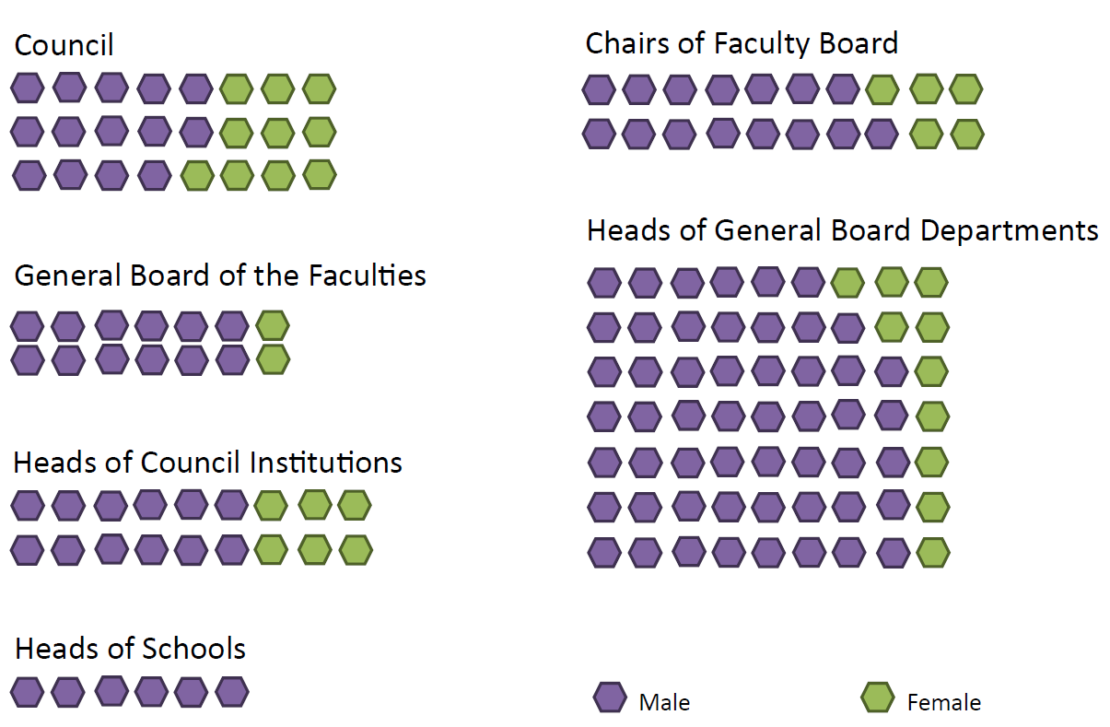

Figure : Pyramid of Power

### 3.2.7 Equal Pay Reviews

The University has been conducting regular equal pay reviews since 2008. These are published biennially on the University website via The Reporter[15]. The report is produced by the Human Resources Division and overseen by GEG and the Equal Pay Review Group (EPRG). The EPRG is comprised of members of the Human Resources Division, Trade Union representatives, and representatives from University Schools and Departments[16].

## **3.3 Ethnicity and Nationality**

The 2012/13 work on InterConnect sought to broaden the focus of the University on race equality to cover Black, Asian, Chinese, Mixed and White Other ethnic groups. This helps to better reflect the legal definition of Black and Minority Ethnic (BME), which includes any group other than White-British. Consultations were held with all of the staff groups to gauge their experiences at the University and were reported to the Equality and Diversity Committee which has informed the InterConnect Action Plan.

### 3.3.1 Groups and Initiatives

On 19 June 2014, the University hosted *The World in Cambridge* to formally launch the InterConnect initiative. This celebratory and inclusive event featured musicians, dancers, singers and speakers highlighting the diversity that comprises the University and the local community. Over 300 people were entertained by a Chinese Lion Dance, Irish Dancers, Yoruba songs, Greek poetry, British Indian poetry, Spanish and French songs, Harp and Pipa music as well as a talk on the history of the local Romany community.

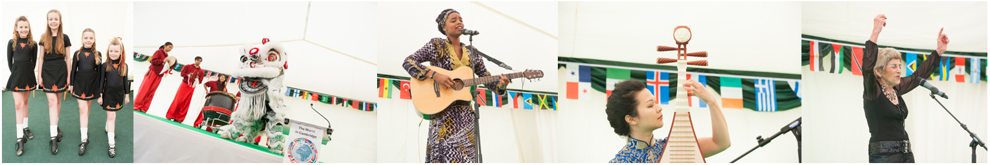

The University further consults with staff through the BME Staff Network[17]. As a result of the InterConnect review, the network will be renamed The World In Cambridge. The University approved the InterConnect Action Plan, which focuses on senior level representation of BME and White Other, continued benchmarking in the sector and nationally, and to improve institutional intercultural awareness. The plan provides a framework for progressing race equality and identifying actions and measures to be taken between 2014 and 2017[18].

### 3.3.2 Ethnic Groups

The University includes representatives from a variety of ethnicities represented in Table 3.

Table : Ethnicity count

|  |  |  |
| --- | --- | --- |
| **Ethnicity** | **Count** | **%\*** |
| Arab | 14 | 0.2% |
| Asian or Asian British - Bangladeshi | 8 | 0.1% |
| Asian or Asian British - Indian | 203 | 2.4% |
| Asian or Asian British - Pakistani | 20 | 0.2% |
| Black or Black British African | 34 | 0.4% |
| Black or Black British Caribbean | 21 | 0.2% |
| Chinese | 293 | 3.4% |
| Mixed Ethnicity | 117 | 1.4% |
| Other Asian Background | 148 | 1.7% |
| Other Black Background | 10 | 0.1% |
| Other ethnic background | 75 | 0.9% |
| White - British | 5622 | 65.7% |
| White - Other | 1995 | 23.3% |
| Unknown | 2175 | * % of total, excluding unknowns |
| **Total** | **10735** |

Overall, of the 80% who disclosed their ethnicity, 11% are BME (Figure 11) which compares to 12.3% reported by the Russell Group Universities (RG) in 2012/13. The largest BME group represented are Chinese who account for 3.4% of those who disclosed their ethnicity.

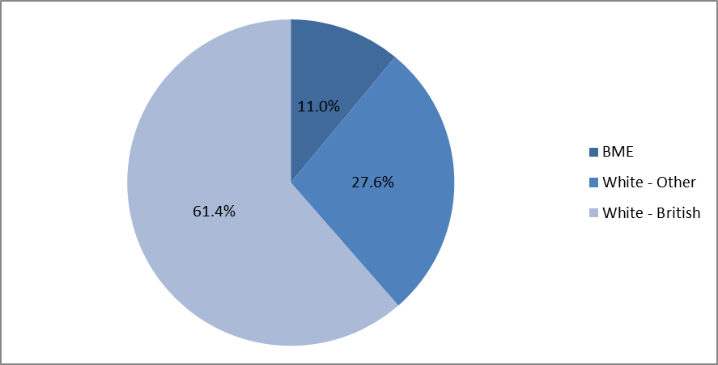

Figure : BME, White - Other, White - British pie chart

### 

### 3.3.3 Nationality

There are 104 nationalities represented at the University of Cambridge. Non-UK nationalities make up 32.1% of the University staff population (Figure 12).

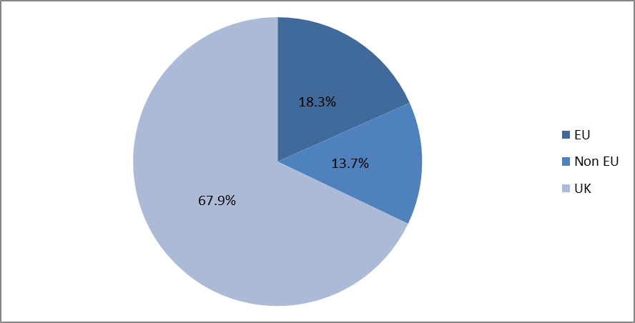

Figure : Nationality pie chart

### 3.3.4 Staff groups and grades

The Researcher group contains the highest proportion of BME (20%) and White Other (42.9%) staff which corresponds with the lowest proportion of respondents with UK Nationality (44.2%) (Figure13). The University does not hold nationality data for 17.5% of staff.

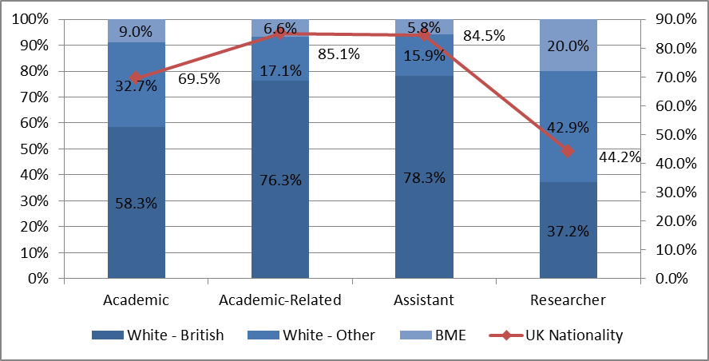

Figure : Staff groups by ethnicity and nationality

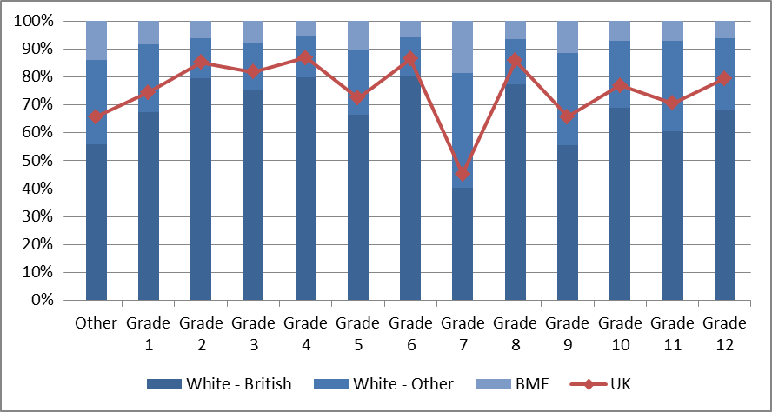

Figure : Staff grades by ethnicity and nationality

Grade 7 has the largest proportion of BME staff at 18.6%, this corresponds with having the lowest proportion of respondents with UK Nationality at 45.3% (Figure 14).

### 3.3.5 Employment status

36.8% of BME staff are on a fixed term contract compared to their White - British counterparts for whom 15.9% of contracts are fixed term. However, all groups seem to have approximately equal representation of Established Academics with White – Other, marginally above by 1.6% (Figure 15).

Figure : Employment status by ethnicity

## **3.4 Disability**

During 2012-13, the University established a Wellbeing Steering Group to support the needs of disabled staff. This brought together different support services including Occupational Health, Human Resources, the Staff Counselling Service, the Chaplain to the University Staff, the trade unions and the E&D section. In 2013/14 People Matter Week was developed as part of the Wellbeing strategy and supported by the Disabled Staff Network.

### 3.4.1 Groups and initiatives

Disabled Staff Network (DSN)[19]

Alongside the University's other Diversity Networks the DSN provides information and support to staff, assists with the co-ordination of diversity events and helps the University to progress equality

People Matter Week (PMW)[20]

In 2014, the PMW event took place in late June 2014. The University recognises the importance of addressing issues related to stress and wellbeing and actively encouraged staff to take part in a wide range of activities. PMW events (yoga, badminton, stress relief, unconscious bias, researcher techniques and University tours) totalled 30 in number, attracting more than 800 bookings overall.

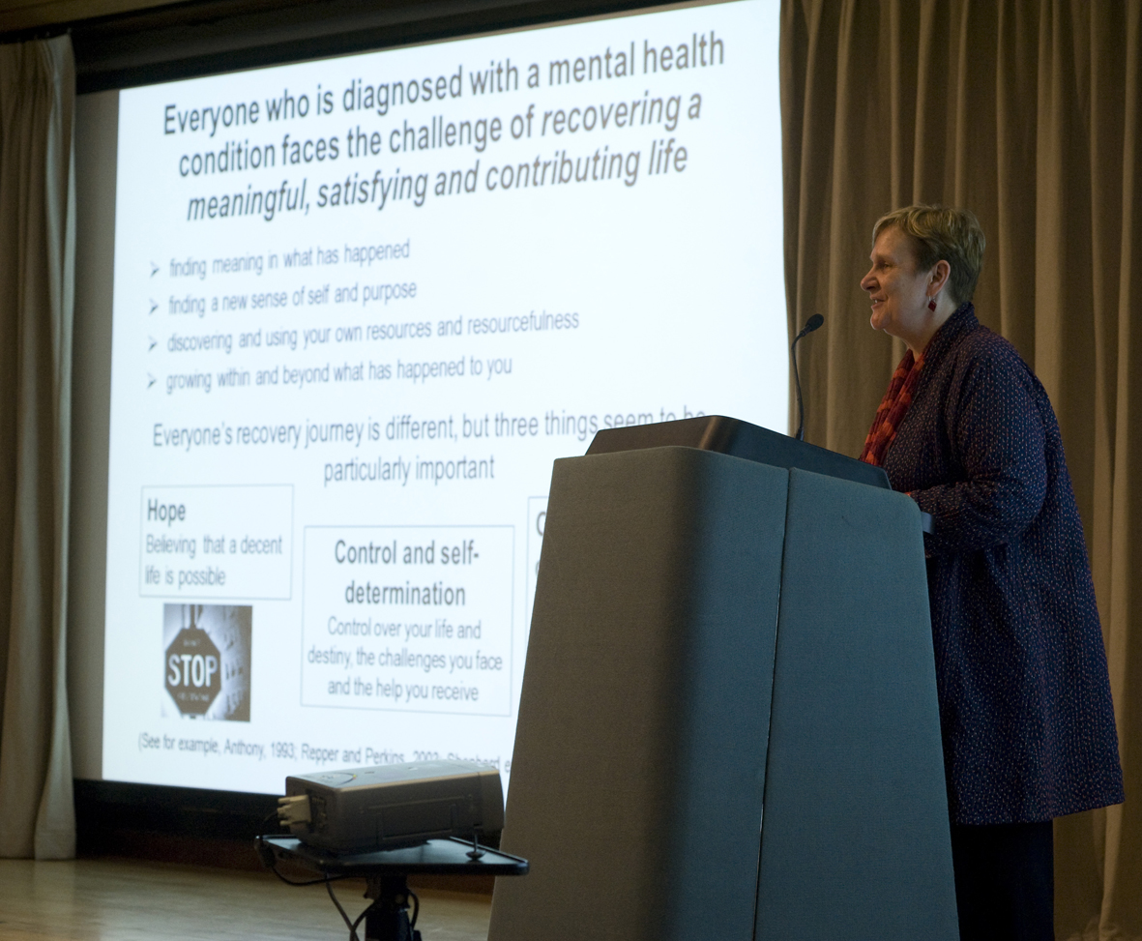Events

Figure : Disability lecture - Rachel Perkins

For International Day for Disabled People a production of autobiographical piece “*Could Be Anyone”* based on the adolescence of a Cambridge dyslexic was held at the Howard Theatre. The Annual Disability Lecture presented by the Disability Resource Centre (DRC)[21] featured a talk by Dr Rachel Perkins, OBE, mental health expert and Mind Champion of the Year 2010 (Figure 16).

### 3.4.2 Staff groups and grades

14.6% of all employees asked about disability responded to the question, with 2.7% (294) disclosing they had a disability. As personal information is now being collected via online recruitment this will allow the University to request data from employees at the beginning of their employment. It is expected that this will increase overall disclosure rates. 49% of those who disclosed a disability were categorised as ‘Unspecified’ (Table 4).

Table : Disability categories

|  |  |
| --- | --- |
| **Disability Category** | **%\*** |
| Blind or a serious visual impairment uncorrected by glasses | 1% |
| Deaf or serious hearing impairment | 6% |
| Long standing illness or health condition e.g. cancer, HIV, diabetes etc. | 19% |
| Mental health condition, such as depression, schizophrenia or anxiety disorder | 6% |
| Physical impairment or mobility issues e.g. difficulty using arms or legs | 8% |
| Social/communication impairment e.g. Asperger's or other autistic disorder | 1% |
| Specific learning difficulty such as dyslexia, dyspraxia or AD(H)D | 11% |
| Unspecified disability | 49% |
| **Total** | **100%** |
| *% of staff who disclosed a disability excluding unknowns |  |

The disclosure rate by staff grade was above average for Grades 1-9 with the peak at Grade 7 (18.8%) and generally decreases as the grade increases (Figure 17).

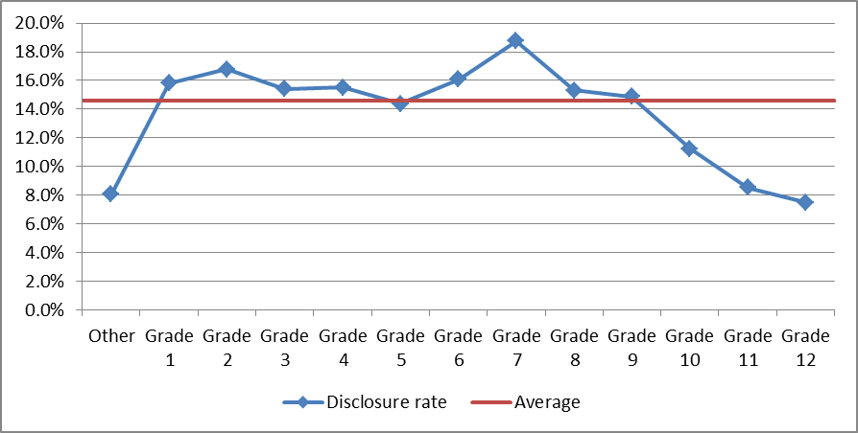

Figure : Disability disclosure rate by grade

Among staff groups, Academic-related had the highest disclosure rate at 17.5% with Academics at the bottom end with 10.2%, Researchers at 16.0% and Assistant staff at 14.0%. 23.8% of staff with a disability work part-time, compared to 20.0% overall. 13.2% of staff with a disability are on a fixed term contract, compared to 26.0% of staff overall.

There is no clear difference in disclosure rate between those who are on fixed-term versus permanent contracts or between those who worked part-time and full-time.

## **3.5 Age**

The median age of staff at the University on 31 July 2014 was 41 years with a mean of 42 which shows a slight decrease of one year in both for the 2012/13 data. The percentage of female staff represented in age groups decreases as the age increases (Figure 18).

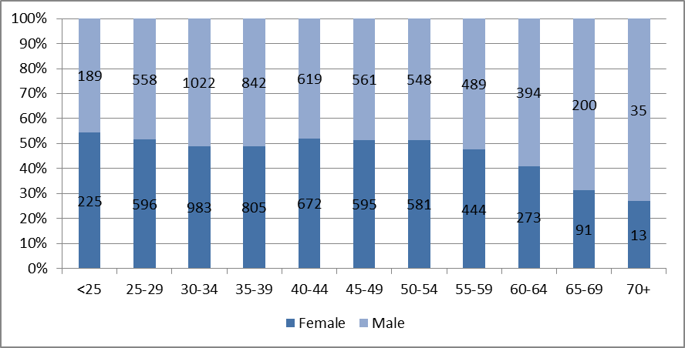

Figure : Age by gender

## **3.6 Other Equality Areas**

The protected characteristics defined under Section 4 of the Equality Act 2010 are:

• Age

• Disability

• Gender Reassignment

• Marriage and Civil Partnership

• Pregnancy and Maternity

• Race

• Religion or Belief (including lack of belief)

• Sex

• Sexual Orientation

The University has been providing an opportunity for staff to disclose information on sexual orientation and religion or belief through the ESS since 2012 in line with the request by the Higher Education Statistics Agency (HESA).

### 3.6.1 Sexual Orientation and Gender reassignment

The University has a vibrant LGBT staff network[22] which engages in social activities, events and talks as well as contributing to the Equality and Diversity Consultative Forum. LGBT staff are supported by the network as well as Equality Champion Dr Nick Bampos.

The University holds sexual orientation data for 8% (887) of the employee population. Of this 8%, 9% (89) identify as lesbian, gay, bisexual or other. With online recruitment, as well as sign-posting for existing staff, it is anticipated that disclosure rates will increase to a level where more detailed analysis can be undertaken.

### 3.6.2 Religion or Belief

Faith and Belief in Practice is a project provided through the Chaplaincy Development Group (CDG). The CDG is a partnership between the University, Trinity College and Great St Mary’s Church and supports the work of the Chaplain to University Staff. The CDG reports to the E&D committee.

Data for Religion or Belief is held for 8% of University staff. 53.6% (459) have selected ‘no religion’ with the next highest group at 37.5% (321) selecting ‘Christian’ with the remaining 7 selections adding up to 8.9%. As with sexual orientation, it is anticipated that disclosure rates will increase such that detailed analysis can be undertaken.

# 4.0 Students

Equality and Diversity issues relating to teaching and learning fall within the remit of the General Board’s Education Committee’s Standing Committee on Equality and Diversity (GBEC’s E&D Standing Committee).

The University’s Equality and Diversity Section and GBEC’s E&D Standing Committee work together to support the University in progressing equality across the institution and to provide a formal channel for involving students. There is a student representative from the Cambridge University Students' Union (CUSU) on GBEC’s E&D Standing Committee and student representation for both Undergraduate and Graduate students on the E&D Committee. In addition, the E&D Section hosts a Student Links network consisting of student representatives from different minority or disadvantaged groups.

Additionally, the University Disability Resource Centre (DRC) provides a confidential, professional, and accessible service for disabled students and those staff supporting them. The DRC supports individuals with any impairment/disability, medical matter, or injury who are current or prospective students. In 2013-2014 data analysis disaggregated by gender, disability and ethnicity were included in the summary report of National Student Survey (NSS) results 2014, considered internally by the General Board’s Education Committee and its Standing Committee on Equality and Diversity. Disaggregated data was also reported against gender, age, and ethnicity for the Postgraduate Taught Experience Survey in 2014. When compared with the sector satisfaction results for each category, no significant concerns were identified. Notably, Cambridge students recorded as having declared a disability reported to be more satisfied than those with no known disabilities in a number of learning and teaching categories in the NSS. This was in contrast to sector results.

The following information is a summary of student figures sourced from the University’s Student Statistics Office. Comparative data is sourced from HESA via the Higher Education Information Database for Institutions. In addition to the University wide data detailed below, the General Board’s Learning and Teaching Reviews[23] provide a further opportunity for student data to be interrogated at the Faculty and Departmental level as they relate to the protected characteristics.

## 4.1 Gender

### 4.1.1 Student numbers

Figure 19: Student numbers by gender (1 December 2013)

In 2013-14, female students comprised 46.0% of all undergraduate students and 44.6% of all postgraduate students (Figure 19). The ratio of female postgraduates to female undergraduates is comparable to the ratio of male postgraduates to male undergraduates (62% and 65% respectively).

Figure 20: Undergraduate student numbers by subject gender (2013-14)

The percentage of female undergraduate students studying subjects in STEMM is 35.6% compared with 58.0% studying Arts and Humanities subjects (Figure 20). Cambridge continues to be committed to programmes such as Athena SWAN and WiSETi to seek to encourage female participation in STEMM subjects.

### 4.1.2 Undergraduate Admissions

Figure 21: Undergraduate admissions by gender (October 2013)

In 2013 there were more applications to the University from prospective students who were male. There was a marginal difference in the percentage of female students who applied and the percentage of female students who were offered places.

With reference to data on UCAS applications and acceptances, the proportion of females to males applying to Russell Group Universities, on average, is the same proportion recorded against acceptances (47% and 53% respectively). This is true for the University of Cambridge, notwithstanding that there is a higher percentage of male to female applicants. As previously reported, this may reflect the differing mix of academic disciplines within the Russell Group Institutions and Cambridge’s offerings in STEMM related subjects (see 4.1.1).

As a collegiate University, undergraduate admissions fall within the remit of the Colleges, however, the Undergraduate Admissions Committee (a joint University and College Committee) considered an Equality Assurance Assessment in relation to recruitment and widening participation in 2013-14. Analysis shows that once subject mix is taken into account, admission by gender to the University (47:53 female to male) broadly reflects national full time undergraduate intake. There was no evidence to suggest that prospective students face unequal access to recruitment or widening participation initiatives based on their gender.

### 4.1.3 Graduate Admissions

Figure 22: Graduate admissions by gender (2013-14)

In 2013-14 applications were received from 8,752 males and 7,017 females (56% and 44% respectively). Of those who accepted offers from the University, 1,985 were male and 1,579 were female (56% and 44% respectively).

### 4.1.4 Undergraduate degree attainment by gender

|  |  |  |  |
| --- | --- | --- | --- |
|  | **Class I** | **Class II Division I** | **Class II Division II and lower** |
| Men | 29.1% | 48.4% | 22.6% |
| Women | 19.7% | 59.6% | 20.7% |

The percentage of women gaining first class examination results was 19.7% compared with 29.1% of males. This has been a source of attention for GBEC’s E&D Standing Committee in 2013-14 given that a more granulated analysis is needed for any meaningful comparison. The Committee, in conjunction with the Senior Tutor’s Standing Committee on Education, continue to evaluate the data and seek appropriate resolution of concerns that arise.

The GBEC’s E&D Standing Committee is developing a programme of work for the next academic year which will gather evidence on good practice adopted by Faculties/Departments and Colleges in addressing gender attainment issues.

## 4.2 Ethnicity

### 4.2.1 Student numbers

Figure 23: student numbers by known ethnicity (2013-14)

Students from a BME background made up 23.2% of undergraduate students and 33% of postgraduate students in 2013-14 (Figure 23).

### 4.2.2 Undergraduate degree attainment by ethnicity

|  |  |  |  |
| --- | --- | --- | --- |
|  | **Class I** | **Class II Division I** | **Class II Division II and lower** |
| White | 21.5% | 47.1% | 31.4% |
| BME | 21.1% | 43.2% | 35.7% |

The percentage of white students gaining first class examination results was 21.5% compared with 21.1% of BME Students.

In 2013-14 CUSU continued to campaign around the specific needs of students who identify with any of the protected characteristics. The GBEC’s E&D Standing Committee has invited the student representative on the Committee to report back at its first meeting of the next academic year on such activities as they relate to BME students in 2013-14.

## 4.3 Disability

### 4.3.1 Student numbers

Figure 24: Student numbers by disability (2013-14)

960 and 393 undergraduates and graduates (equating to 8.1% and 6.0% respectively) disclosed a disability in 2013-14 (Figure 24). These figures increased by 0.7% and 0.9% respectively from 2012-2013.

### 4.3.2 Undergraduate degree attainment by disability

|  |  |  |  |
| --- | --- | --- | --- |
|  | **Class I** | **Class II Division I** | **Class II Division II and lower** |
| No Disability | 21.5% | 45.8% | 32.7% |
| Declared Disability | 20.5% | 48.7% | 31.2% |

The percentage of students with no declared disability gaining first class examination results was 21.5% compared with 20.5% of students who declared a disability.

In 2013-14 the University made amendments to its Code of Practice on reasonable adjustments to teaching and examining for disabled students, including an extension of recording permissions (in specific circumstances) to seminars and supervisions and the introduction of a baseline provision of specifically identified adjustments for students with Specific Learning Difficulties (SpLDs) . The amendments also strengthened sections related to disclosure and anticipatory duties as well as the process used to disseminate information on recommended student support; the Student Support Document (SSD). The Code of Practice also contains the procedure regarding consideration of requests for alternative modes of assessment.

## 4.4 Age

Undergraduate and postgraduate students had a median age of 18 and 24 respectively at time of admission to the University.

## 4.5 Other Equality Areas

The University of Cambridge does not currently monitor or report on the Equality Act 2010 protected characteristics of sexual orientation, religion or belief, or gender identity for its students. The University engaged with HESA’s consultation in 2011 on introducing these categories to the student record and notes that it is still optional as to whether institutions return this information in their HESA return. The University continues to review its internal mechanisms for capturing and storing any such data so that it is prepared, if required, to return these data to HESA in the future.

Equality and Diversity guidance documents for these protected characteristics are considered by the Equality and Diversity section and GBEC’s Standing Committee on Equality and Diversity. In 2013-14 a draft guidance document on Students Undergoing Gender Reassignment was circulated to the Committee.

The Committee also noted that a working group has been established to consider a policy on faith-related provision for university examinations. Work is ongoing in both these areas.

# 5.0 Equality Analysis- Equality Assurance Assessments

The University is committed to developing and maintaining an institution where staff and students from all backgrounds can flourish. In keeping with institutional core values of freedom of thought and expression and freedom from discrimination, the University aims to develop policy and services that have a pro-active and inclusive approach to equality. The EAA process supports this commitment and also ensures the University meets its equality duties as set out within the Equality Act 2010.

The process enables EAA Assessors to identify and consider any likely equality impact when developing or reviewing policies to adopt, or functions to implement. By using this evidence-based approach, the University is able to make higher quality decisions and consciously think about how a policy or function might support the fostering of good relations amongst different groups. The EAA process is a key tool in embedding equality into the core functions of the organisation and enabling the University to show due regard in fulfilling its legal obligations in line with the Public Equality Duties.

The University of Cambridge’s Equality Assurance Assessments process is now a fully embedded system and is overseen by the EAA Review Group (EAARG). The EAARG meets twice yearly to provide formal consideration of the EAA process, endorse EAA completion and respond to any issues or outcomes identified. The EAARG reports regularly to the E&D Committee and University-wide EAA activity is reported annually within this report.

It is widely recognised that the majority of EAAs undertaken to assess the equality impact of policy and procedure fall within the Human Resources Division with other University areas using the process as required. An initial relevance check has been introduced to consider the requirement for policies to undergo the EAA process. Where it is irrelevant to carry out an EAA this is recorded and reported to the EAARG on an annual basis.

An example of a notable EAA is the EAA on the Code of Practice on the Selection of Staff. This EAA was completed as part of the Research Exercise Framework (REF) as required by the Higher Education Funding Council. The University of Cambridge was highly commended for the completion of this EAA which few other Universities undertook.

Since the last Information report 2011-12, 21 EAAs have commenced. 4 EAAs are now fully concluded. A further 5 EAAs have been endorsed by the EAARG and it is envisaged these will be completed by the end of the current academic year.

All EAAs which have reached Stage 3 are recorded on the EAA schedule (Appendix 3) which is published. The Schedule plays a key role in the internal management of the EAA process.

# Appendix 1

## **Staff - Definitions and notes**

This Equality & Diversity Information Report is derived from the HR CHRIS[24] system at a 31 July 2013 census date.

The staff numbers presented are of individual staff members (headcount) rather than full time equivalent (FTE). Where staff had multiple contracts or in cases where contracts involve more than one activity, a set rule was applied for non-Academic staff. The individual was assigned to the position with the highest FTE, or if the FTEs were identical, the staff member was assigned to the position that they had held for the longest period of time. In cases where Academic staff held both an Academic and Research post, they were assigned to their Academic role.

Positions held in association with a substantive full-time appointment, including Associate Lectureships, Heads of Department and Chairs of Faculty Boards, were not counted.

Where staff information categories would include numbers of less than five, information has not been included in accordance with Higher Education Statistics Agency (HESA) policy in order to protect the confidentiality of individuals[25].

Due to rounding to one decimal place, some total percentages may not equal 100%. No statistical testing has been conducted due to the small number of staff in many of the categories and protected groups.

## **Age (staff)**

This report uses the following age categories:

– Under 25

– 25 to 29

– 30 to 34

– 35 to 39

– 40 to 44

– 45 to 49

– 50 to 54

– 55 to 59

– 60 to 64

– 65 to 69

– 70 and over

## **Disability (staff)**

Disability is recorded within the CHRIS system using the HESA staff categories[26]. HESA has a number of disability fields for staff disclosure at either recruitment or during employment at the University.

## **Ethnicity (staff)**

Some ethnicity data has been combined for easier comparison so that all Mixed Ethnicities (White and Asian (44), White and Black African (12), White and Black Caribbean (5) and Other Mixed (56)) are encompassed in Mixed Ethnicity. Historically only ‘White’ was recorded whereas the University now records White – British, White – Irish and White – Other as such for the purposes of this data, ‘White’ (365) has been included within White – British (5257).

Ethnicity has been aggregated into these groups:

Arab

Asian or Asian British - Bangladeshi

Asian or Asian British - Indian

Asian or Asian British - Pakistani

Black or Black British African

Black or Black British Caribbean

Chinese

Mixed Ethnicity

Other Asian Background

Other Black Background

Other ethnic background

White - British

White - Other

## **Science, Technology, Engineering, Mathematics and Medicine Departments (STEMM)**

This report uses a generic classification of academic departments from the HESA staff record. This is in line with STEMM departments covered by the Athena SWAN Charter (www.athenaswan.org.uk). At the University of Cambridge this includes employees in the following Schools: Biological Sciences, Clinical Medicine, Physical Sciences and Technology (with the exception of the Judge Business School and affiliated Centres).

## **Staff at the University of Cambridge**

Any person who holds a University office or post and has a University contract of employment is considered to be an employee. Employees are categorised as Academic, Academic-related, Assistant or Researcher on the basis of the main duties of their post.

Full-time staff are defined for the purpose of this report as being employed at 1 FTE (full-time equivalent). Part-time staff are defined as being employed at less than 1 FTE.

Established Academic and Academic-related staff hold University Offices as defined in the Statutes and Ordinances of the University of Cambridge[27]. Unestablished staff are those Academic and Academic-related staff who do not hold University Offices or are in Research positions.

Academic roles are further disaggregated into Academic staff type, namely University Lecturer, Senior Lecturer, Reader and Professor.

Each post is assigned to a specific grade within the grading structure 1–12[28]. The grades overlap with staff groups so members of different staff groups can be employed on the same grade, but with different core roles and responsibilities.

A number of University roles have been grouped into the category ‘Other’ as they have not been assigned to a specific grade. This category includes staff employed in some Clinical roles, as Marie Curie Fellows, Special Appointments or those with blank records[29].

Staff are defined as having either permanent (open-ended) or fixed contracts. Those on fixed contracts are employed for a fixed period or have an end date on their contract of employment.

## **Benchmarking**

Where useful, data from the other Russell Group universities has been provided for benchmarking purposes. These data have been sourced from HESA via the Higher Education Information Database for Institutions (HEIDI) online tool. The latest available information was for 2012-13 year.

## **Students - Definitions and notes**

The enclosed student figures are a summary of information sourced from reports and publications produced by the Student Statistics Office, Graduate Admissions and Cambridge Admissions Office. Further detailed information for all students is available from these sections. The information has been presented in line with the requirements of the Equality Act 2010 public sector equality duty which obliges higher education institutions to publish information about the people affected by its policies and practices; in this case students. No significance testing has been performed due to the low numbers of students in many of the protected groups.

All student figures are the latest available and in most cases are for the academic year 2013-14 unless otherwise specified. Information regarding postgraduate admissions is reported from 2013-14.

For full information and definitions on student figures please refer to the CamDATA website: www.admin.cam.ac.uk/univ/camdata/.

Please note that due to rounding to one decimal place, some total percentages may not equal 100%.

# Appendix 2 – Letter to Times Higher Education

# Promoting gender balance

20 February 2014

*In just over two weeks’ time, many organisations, charities and individuals will be taking part in International Women’s Day, which this year takes as its theme “inspiring change”, encouraging “advocacy for women’s advancement everywhere and in every way”. We think now is a good time for the higher education sector to celebrate the progress that has been made in advancing gender equality, but also to ask what more can be done, and how.*

*“We” are a group of staff at the University of Cambridge who believe that more should be done to broaden how we judge and value success in UK higher education. Conventional success in academia, for example a promotion from reader to professor, can often seem as if it is framed by quite rigid outcomes – a paper published in a leading journal, or the size and frequency of research grants – at the expense of other skill sets and attributes. Those engaged in teaching, administration and public engagement, to name just three vital activities, can be pushed to the margins when specific, quantifiable outcomes take all.*

*Of course, assessment and ranking play an important role in the responsible and regulated pursuit of academic excellence. But problems arise if certain criteria for success benefit men more than they do women.*

*Our experience at Cambridge, where we recently surveyed 126 female academics and administrators on this subject, suggests that this is indeed the case. Women value a broader spectrum of work-based competencies that do not flourish easily under the current system. And a system that inhibits the progression of talented academics and administrators is one that limits universities’ ability to contribute positively to society.*

*We acknowledge that Cambridge, like other institutions up and down the country, must do more in this regard, and we are committed to making progress in addressing our own gender imbalances. But how else can we improve? First, we would like to stimulate debate on these issues so that gender progression remains a priority at the highest levels within the sector. Second, we think there are opportunities to build into assessment processes – for example, academic promotions – additional factors that reward contribution from a much wider range of personality and achievement types.*

*A broader definition of success within the sector will bring benefits not only to women – and indeed men – working in universities, but also to society as a whole.*

**Jeremy Sanders, pro-vice-chancellor for institutional affairs, University of Cambridge  
Dame Athene Donald, University of Cambridge gender equality champion  
Nicola Padfield, master, Fitzwilliam College  
Richard Prager, head, School of Technology  
Hannah Critchlow, department of pathology  
Kusam Leal, School of the Physical Sciences  
Madeleine Arnot, Faculty of Education  
Nicky Athanassopoulou, Institute for Manufacturing  
Shima Barakat, Cambridge Judge Business School  
Claire Barlow, department of engineering  
Catherine Barnard, Faculty of Law  
John Bell, Faculty of Law  
Dame Carol Black, principal, Newnham College  
Brendan Burchell, head, department of sociology  
Ann Cartwright, Wellcome Trust/Cancer Research UK Gurdon Institute  
Joya Chatterji, Faculty of History  
Jane Clarke, department of chemistry  
Nicola S. Clayton, department of psychology  
Tim Crane, Knightbridge professor of philosophy  
Martin Daunton, head, School of the Humanities and Social Sciences and master, Trinity Hall  
Judith Driscoll, department of materials science and metallurgy  
Patricia Fara, senior tutor, Clare College  
Rachel Fogg, department of engineering  
Sarah Foreman, University of Cambridge estate management division  
Jennifer C. French, division of archaeology  
Laurie Friday, School of the Physical Sciences  
Jane Goodall, department of medicine  
Valerie Gibson, Cavendish Laboratory  
Fiona Gilbert, head, department of radiology  
Emma Gilby, department of French  
Liz Hide, University of Cambridge Museums  
Deborah Howard, department of history of art  
Ann Louise Kinmonth CBE, emeritus professor of general practice  
Judith Lieu, Faculty of Divinity  
Theresa M. Marteau, Behaviour and Health Research Unit  
Duncan Maskell, head, School of the Biological Sciences  
Jessie Monck, University of Cambridge Personal and Professional Development  
Rachel Oliver, department of materials science and metallurgy  
Andy Parker, head, Cavendish Laboratory  
Sharon Peacock, department of medicine  
Karina Prasad, head, Office of Postdoctoral Affairs  
Wendy Pullan, department of architecture  
Margaret S. Robinson, Cambridge Institute for Medical Research  
Ruchi Sinnatamby, School of Clinical Medicine  
Rebecca Simmons, Medical Research Council Epidemiology Unit  
Alison Smith, department of plant sciences  
Annabel Smith, Cambridge Institute for Medical Research  
Koen Steemers, head, department of architecture  
Philippa Steele, Faculty of Classics  
Dame Barbara Stocking, president, Murray Edwards College  
Suzy Stoodley, department of plant sciences  
Abir Al-Tabbaa, department of engineering  
Liba Taub, director and curator, Whipple Museum of the History of Science   
Susie White, Faculty of Asian and Middle Eastern Studies  
Emma Wilson, department of French  
Elizabeth Tilley, Faculty of English**

# Appendix 3



1. http://www.cam.ac.uk/women-at-cambridge
2. http://www.equality.admin.cam.ac.uk/equality-and-diversity-cambridge/university-equality-champions
3. http://www.equality.admin.cam.ac.uk/files/objectives_201216.pdf
4. https://camtools.cam.ac.uk/join/equal_div
5. Disability recording data has been updated and now records those who disclose they do not have a disability as such instead of amongst the ‘not known’ category
6. Visit http://www.hrsystems.admin.cam.ac.uk/systems/systems-overview/employee-self-service-ess
7. http://www.equality.admin.cam.ac.uk/files/gender_action_plan_2014_final.pdf
8. http://www.equality.admin.cam.ac.uk/diversity-networks/womens-staff-network
9. http://www.equality.admin.cam.ac.uk/equality-and-diversity-cambridge/senior-gender-equality-network
10. http://www.equality.admin.cam.ac.uk/equality-and-diversity-cambridge/gender-equality-group
11. http://www.equality.admin.cam.ac.uk/projects/wiseti
12. http://www.equality.admin.cam.ac.uk/projects/athena-swan
13. Recognising commitment to advancing women's careers in science, technology, engineering, maths and medicine (STEMM) employment in higher education and research.
14. http://www.equality.admin.cam.ac.uk/equality-and-diversity-cambridge/university-equality-champions
15. http://www.admin.cam.ac.uk/reporter/2012-13/weekly/6287/section1.shtml#heading2-5
16. Visit http://www.equality.admin.cam.ac.uk/equality-and-diversity-cambridge/gender-equality-group
17. http://www.equality.admin.cam.ac.uk/diversity-networks/world-cambridge-network
18. http://www.equality.admin.cam.ac.uk/projects/interconnect/interconnect-action-plan
19. http://www.equality.admin.cam.ac.uk/diversity-networks/disabled-staff-network
20. http://www.peoplematterweek.admin.cam.ac.uk/
21. http://www.disability.admin.cam.ac.uk/
22. http://www.equality.admin.cam.ac.uk/diversity-networks/lgbt-staff-network
23. <http://www.admin.cam.ac.uk/offices/education/reviews/>
24. Cambridge Human Resources Information System
25. http://www.hesa.ac.uk/index.php
26. For details on all HESA staff categories go to http://www.hesa.ac.uk/dox/datacoll/C11025/11025.pdf?v=d41d8cd98f00b204e9800998ecf8427e
27. http://www.admin.cam.ac.uk/univ/so/2009/statute_d.html#heading2-1
28. http://www.hr.admin.cam.ac.uk/pay-benefits/salary-scales
29. Please note: Clinical Professors, Readers, University Lecturers, Senior Lecturers, Research Associates and Senior Research Associates have been mapped to the University’s grading system for the purposes of this information analysis.