**2016-17 Equality and Diversity Information Report**

University of Cambridge

Equality@admin.cam.ac.uk

Published 31 January 2018



# Foreword

The Equality and Diversity Information Report 2016-17 provides a summary of activity in support of the University’s Equality and Diversity Strategy 2016-21, which maps the University’s direction over a five year period.

This report also provides an overview of equality information on our staff and student communities. The data contained in this report are used to inform the University’s efforts to ensure an inclusive environment for work and study and to measure the impact of any changes. The report is presented mindful of guidance regarding our obligations under equality law which covers the protected characteristics of age, disability, gender reassignment, marriage (and civil partnership), pregnancy and maternity, race, religion and belief, sex and sexual orientation.

A highlight of the year was that more women applied for academic promotion compared to the previous three years and 83 per cent of women who applied for Professorships were successful. . This result validates the number of University initiatives that have focussed on increasing the number of women in senior roles.

Our focus on building an inclusive, supportive environment for all staff and students led to the University’s new partnership to provide access to emergency care for dependants through My Family Care as well as the launch of WellCAM. This year has also seen the beginning of preparations towards a Race Equality Charter submission in 2018. This Equality and Diversity Information Report 2016-17 has been prepared for publication by our Equality and Diversity Section, which is part of the University’s Human Resources Division. It is governed by the University’s Equality and Diversity Committee.

**Professor Eilís Ferran FBA**

**Pro-Vice-Chancellor for Institutional and International Relations**

**Chair of Equality and Diversity Committee**

## 

Contents

1. Foreword 2

2. Introduction 36

3. Part 1 – Overview of progress 38

Objective 1: Promoting Diversity and Inclusion 38

Objective 2: Tackling Gender Inequality 39

Objective 3: Addressing student disadvantage 40

Objective 4: Ensuring an Inclusive Environment for Work and Study 45

Objective 5: Building Engagement and Best Practice 49

4. Part Two – Key Facts and Figures 51

1 Staff Key facts and figures 51

1.1 Gender 52

1.2 Ethnicity and Nationality 58

1.3 Disability 62

1.4 Age 62

1.5 Sexual Orientation and Gender reassignment 63

2 Student Key facts and figures 65

2.1 Gender 65

2.2 Ethnicity 68

2.3 Disability 69

Appendix 1 72

Staff - Definitions and notes 72

Age (staff) 73

Disability (staff) 73

Ethnicity (staff) 73

Arts, Humanities, Social Sciences, Business and Law Departments (AHSSBL) 73

Science, Technology, Engineering, Mathematics and Medicine Departments (STEMM) 74

Benchmarking 74

Students - Definitions and notes 74

Appendix 2 – Equality Assurance Assessment Schedule 75

# Introduction

The University of Cambridge is committed to providing the highest quality environment for employment, research and study and to ensuring the wellbeing of nearly 12,000 staff and 20,000 students. Our institutional values of freedom of expression and freedom of thought are underpinned by the principles of mutual respect and inclusivity, and celebration of the rich diversity of our community.

The University publishes this report by 31 January each year in accordance with the Equality Act 2010 (Specific Duties) and as part of its commitment in promoting a positive and fully inclusive work and study environment. Equality and diversity responsibilities lie with several bodies across the University and progress is regularly reported to the University’s governing bodies via the Equality and Diversity Committee[1]. This report and appendices outline the activity that has been undertaken and also provides key information regarding staff and students as required in law.

### Equality and Diversity (E&D) Strategy 2016-2021

In 2016 the University of Cambridge published its E&D Strategy 2016-2021, mapping the University’s direction over the next five years. This strategy, and accompanying Action Plan[2], builds on strong foundations of institutional policy and resource commitment, legal compliance, specific objectives and senior engagement secured over the last few years.

With the aim of taking forward the complex process of embedding equality and diversity into the culture, mind-set and functions of the University, the E&D Strategy seeks both to maintain these achievements and enhance them further. With this aspiration at its centre, the Strategy identifies five key objectives on which to focus, with the aim of bringing about real improvements in these target areas over its duration. These priorities have been identified through consultation and engagement, data analysis, insights gathered from central and local benchmarking, and sector expertise. They add to the University’s well-established core activities of promoting equality and diversity, developing best inclusive practice, and maintaining compliance with equalities legislation.

The five objectives are of equal importance and will contribute to achieving the changes needed to advance our commitments in this area. The role of the University’s annual E&D Information Report is to highlight progress against these objectives, and provide an overview of the initiatives and activities that have taken place over the last year (Part 1 of the report). Part 2 provides a summary of staff and student diversity data for this period, benchmarked where appropriate.

**Equality and Diversity Strategy Objectives**

**2016-2021**

**Objective 1**

**To identify opportunities and barriers related to the recruitment, progression and management of a diverse body of staff, and to achieve greater diversity at senior levels of the organisation**

**Objective 2**

**To tackle gender inequality, addressing particular barriers faced by women in academia, supporting the career progression of academic, research and professional female staff, and taking action to close the gender pay gap**

**Objective 3**

**To address disadvantage in student learning and attainment and issues in student satisfaction in relation to protected characteristics**

**Objective 4**

**To ensure an environment for work and study that is inter-culturally inclusive, supportive of student and staff parents and carers, encourages authenticity and upholds the dignity and respect of all**

**Objective 5**

**To increase engagement in equality, diversity and inclusivity best practice across the collegiate University through participation in training, learning opportunities, joint working and shared objectives**

# Part 1 – Overview of progress

## Objective 1: Promoting Diversity and Inclusion

**To identify opportunities and barriers related to recruitment, progression and management of a diverse body of staff, and achieve greater diversity at senior levels of the organisation**

As shown in Part 2 of this report, the University of Cambridge faces many of the same challenges as the rest of the UK higher education sector, including low representation of women and ethnic minorities at the more senior levels. In 2016-17, the need to address these issues were not only identified as Objective 1 of the E&D Strategy, but was also reiterated in the University’s People Strategy that maps out the University’s HR activities over the period 2016-2021[3].

The overall objective of the People Strategy is to make the University an employer of choice, with a culture and environment that is stimulating and rewarding for its people and provides a competitive advantage to enable the University to meet its core mission. The Strategy defines the priority of fostering a thriving community and a culture of inclusivity, diversity, health and wellbeing as one of its four key areas of action.

This Strategy will take forward actions on building clear and inclusive recruitment, promotion and development processes, which will support increased diversity within the University at all levels.

Cognisant that the diversity of our senior leadership influences not only our strategic priorities and decision-making, but also the role models we provide to our staff, this year saw the launch of an ongoing review in to the membership, profile and accessibility of the University’s influential committees by the E&D section. This work will continue over 2017-18 to identify opportunities, through a further review of committee terms of reference and appointment mechanisms, to increase the diversity of committee membership.

### Equality Champions

Champions are integral to the successful promotion and progression of equality at the University. High profile Champions advocate and influence at senior levels of governance and within the Cambridge community as a whole. They provide points of contact for protected or special interest groups, as well as specialist advice on the development and implementation of policy and best practice. Equality Champions are recognised as playing a central role in disseminating good practice and encouraging the promotion of equalities, demonstrating that the organisation’s culture and core values include respect and positivity.

2016-17 saw the appointment of new Gender, and Race and Inclusion Champions to take office from 1 September 2017. A new Disability and Wellbeing Champion was also established. The new Champions are:

* Gender Equality Champion (Science, Technology, Engineering, Mathematics and Medicine Departments) - Professor Val Gibson
* Gender Equality Champion (Arts, Humanities and Social Sciences Departments) - Professor Sarah Colvin
* Race and Inclusion Champions - Dr Kamal Munir and Dr Mónica Moreno Figueroa
* Disability & Wellbeing Champion and LGBT Champion - Dr Nick Bampos**.**

## Objective 2: Tackling Gender Inequality

**To tackle gender inequality, addressing particular barriers faced by women in academia, supporting the career progression of academic, research and professional women staff, and taking action to close the gender pay gap**

Achieving equal gender representation through all levels of the staff profile and supporting female staff to remain and progress within the institution are a key focus going forward. Staff consultations, surveys and the experience of the wider sector have informed our initiatives and actions.

Policy work on gender was overseen in 2016-17 by the Gender Equality Steering Group (GESG). GESG’s business over the year focussed on the analysis of equal and gender pay data and on investigating the drivers behind the University’s gender pay gap. This work included analysing rates of promotion for academic and professional and support staff (PSS) women and holding focus groups with all staff groups to understand perceptions and experiences of career progression.

The focus on the gender pay gap builds on the regular equal pay reviews the University has been conducting since 2008, leading the sector in this area. These reviews are published biennially on the University website[4]. An Equal Pay Review was published in early 2017 and the University will publish its gender pay gap figures in line with the Government’s new mandatory reporting requirements in March 2018. The gender pay gap, and ways to mitigate it will form an important element of the gender equality work going forward.

### Supporting Career Progression

The University’s Senior Academic Promotions (SAP) process is a key mechanism in increasing the representation of women at higher levels of academia. The University regularly reviews and amends the SAP process and guidance to ensure that the system is fair and equitable to all academic staff. In addition, one-to-one support is provided to academics who are considering applying for promotion through the CV Scheme.

The CV Scheme was developed after analysis of the University’s promotions data, and brings together Lecturers, Senior Lecturers and Readers seeking promotion with senior academics who have extensive experience of the SAP procedures in order to review mentees’ CV and promotion paperwork before it is submitted. In 2016-17, this scheme supported 37 mentees (81.1% female), representing a substantial increase on the previous year.

Results from the annual SAP round are analysed by gender and considered by the University Council and other decision making committees within the University. The data shows that more women put themselves forward for Senior Academic Promotion in 2017 than in the previous three years, especially for Professorships.

In 2017, 8.6% (66) of women in the eligible pool applied for promotion compared with 3.9% (29) in 2016. It is this proportion of the eligible pool which is important as over previous years women have been less likely to put themselves forward for promotion and many of the gender actions centred on the SAP process have sought to rectify this disparity. Not only were women more likely to put themselves forward for promotion, but when success rates across all promotions are considered, women have been more successful than males in 3 of the last 4 years. This year there was an 83% success rate for female applicants for Professorships compared with 55-70% from 2013-2016 inclusive.

### Athena SWAN

The Athena SWAN (AS) Charter addresses gender inequalities in all disciplines, and at all levels of employment in higher education. The University supports departments applying for awards with data resources and expert-led events[5]. The University currently holds a Silver Athena SWAN award and during this year work had been undertaken for the award’s renewal in November 2017. Currently 91% of staff in STEMM Schools are covered by a departmental AS award. Of the 21 eligible AHSSBL Departments, 2 applied for Bronze awards in April 2017 and 3 applied in November 2017. All departments are expected to have applied for an award by the end of 2021. In recognition of the close relationship between the Colleges and the University, Departments include College Teaching Officers in Athena SWAN applications where possible, and the University and Colleges share good practice and initiatives addressing inclusion issues.

The University’s focus in the area of gender equality is also evidenced by the number of high level events it hosts. A particular highlight was the Annual Women in Science, Engineering, Technology Initiative (WISETI) Lecture. This year a panel of speakers, Professor Dame Athene Donald (Master of Churchill and Professor of Experimental Physics), Dr Emily Shuckburgh OBE (British Antarctic Survey climate scientist), and Dr Simon Bittleston (Vice President of Research at Schlumberger Limited) looked at the challenges, opportunities and differences women bring to the world of science.

## Objective 3: Addressing student disadvantage

**To address disadvantage in student learning, and attainment and issues in student satisfaction in relation to protected characteristics**

Equality and diversity issues relating to teaching and learning fall within the remit of the General Board’s Equality and Diversity Education Standing Committee (EDESC), which is supported by Educational and Student Policy and assisted by the E&D section and the Disability Resource Centre. The EDESC supports the University in progressing equality and diversity issues relating to University teaching and learning, and includes student representation. This representation includes representatives from Cambridge University Students' Union (CUSU) and the Graduate Union (GU).

There are a number of independent student networks and autonomous campaigns associated with the Cambridge University Student Union (CUSU). These campaigns are focussed around the specific needs of students who may identify with any of the protected characteristics, defined by the Equality Act 2010, to direct their own activities and highlight issues to the wider University. For information on the definitions and methodology used in this report please refer to Appendix 1.

### Addressing student attainment gaps

During 2016-17, EDESC reviewed data on students’ attainment in relation to protected characteristics starting with gender and ethnicity, and extending to all characteristics for which data could be obtained. It received data on performance of undergraduates at Tripos (subject degree) level for the 2015 and 2016 examinations by protected characteristics where data permitted. In reviewing data on undergraduate students’ BME attainment, the EDESC concluded that, overall, there is evidence that an ethnic attainment gap exists.However, due to the number of BME categories, the statistical significance of any apparent gaps cannot be determined when data is further disaggregated. The sub-committee will review such data annually and monitor trends.

A longitudinal analysis of examination results by ethnicity and gender spanning examination years from 2013-14 to 2015-16 was also commissioned. It was noted that the subject studied was the most significant determining factor to obtaining a first or not and that this potentially conflates results for gender and ethnicity. Analysis also showed that the gender attainment gap narrows progressively through the years and that in a small number of subjects, women achieve more firsts than men. For the 2016 examinations results, it was noted that in a number of disciplines, women perform better in their first year compared to their third year. In terms of ethnicity, BME students tend to have lower results than white students but the sample is highly imbalanced and therefore it is difficult to draw any firm conclusions. EDESC noted that there is a multitude of factors that need to be considered, and that going forward the Committee will liaise closely with the University’s Admissions Office, which is currently undertaking a similar project.

To help address attainment gaps, the Committee explored possibilities of introducing/expanding existing programmes that boost students’ confidence. It further recognised that introducing alternative modes of assessment in the different disciplines may help to address both gender and BME attainment gaps. The sub-committee also received reports and results prepared for the Race Equality Charter submission and discussed the feedback received on those documents.

### Supporting students to succeed

The collegiate University aims to attract students with the greatest potential in the world, regardless of background. In support of this objective, Cambridge is currently engaged in an unprecedented level of additional outreach activity that is designed to reach a diverse range of under-represented groups across the UK.

The outreach and widening participation initiatives aim to give students across the country the opportunity to learn about the University and encourage applications to Higher Education. Much of the work undertaken by the Colleges and the University targets specific under-represented and disadvantaged groups. These groups include: children in care; students eligible (or previously eligible) for free school meals; black, Asian and ethnic minority students; mature learners; and students who live in areas where young people are less likely to participate in Higher Education

Outreach and widening participation activities include:

* the College Area Links Scheme, which was created in 2000, and ‘links’ every local authority in the UK with a Cambridge College; this helps to facilitate the national influence of our outreach activity. This scheme is a tool for communication and a vehicle for outreach efforts that enables the Cambridge Colleges to build effective, coherent relationships with schools and sixth form colleges across the UK, and develop an understanding of local educational contexts.
* The *Cambridge Sutton Trust Summer Schools* are fully-funded, week-long, subject-specific residential events where participants live and study as if they were Cambridge students. Aimed at highly able students from underrepresented backgrounds, the summer schools are designed to help participants make informed decisions about their HE choices and equip them with the academic confidence, skills and knowledge to make a competitive application to a highly selective university.
* In partnership with the Sutton Trust the University has launched the *Sutton Scholars* programme in East Anglia. The programme for students in Years nine and ten aims to address some of the particular challenges faced by predominantly white working class young people living in areas of rural and coastal deprivation and low social mobility
* *Experience Cambridge* is an initiative that has been running since 2012; over two-day visits participants gain an insight into undergraduate teaching and learning at the University, and are given the opportunity to explore their preferred subject area in depth.
* *Insight* is a progressive programme that works with highly able students in Years 9 to 11, with the aim of developing their academic interests and helping them make informed decisions about their future educational choices.
* The *Cambridge University Students’ Union (CUSU) Shadowing Scheme* provides the opportunity for Year 12 state school students and mature learners from widening participation backgrounds to experience life as a Cambridge student. The CUSU Shadowing Scheme is the largest and most established student-led access initiative in the country, and is well known and highly regarded amongst UK state schools.

Beyond admission processes, the collegiate University provides exceptionally intensive and highly individualised support to its students. Regular supervisions involve very small groups and all undergraduates have a Director of Studies, who is typically in their own College and closely manages their academic progress, as well as a personal College-based Tutor to advise and support them on pastoral issues. College-based support is complemented by lectures, seminars, and practical classes organised by Faculties and Departments, which become increasingly specialised in the later years of a course. Students benefit from high quality College accommodation that is available to all undergraduates for at least three years of each course, as well as extensive medical, disability and counselling support. All of this contributes to unusually high academic attainment and a very low drop-out rate. Our ability to identify students likely to succeed and the quality of the educational experience offered to them is demonstrated by the proportion of finalists (c.91.1%) gaining at least Upper Second Class Honours.

Feedback from students recorded in the National Student Survey is consistently high (currently four percentage points higher than the sector average, at 90%). The University has one of the highest continuation rates of any UK higher education institution (currently 98.5% compared to 91.4% for the sector). This is in part a product of high contact hours and very small contact groups, the pastoral care provided by our Colleges and the student support facilities available, but is also assisted by the extensive financial support that we offer to our students. Research undertaken by the University’s Admissions office has shown little significant variation between social groups in terms of their likelihood of completion, but we will continue to monitor this as our access activities contribute to a wider diversity of intake. In addition, as outlined in Objective 5, the University is undertaking work in combating unconscious bias.

### 

### Promoting best practice for inclusive teaching

The General Board’s Education Committee (GBEC), in partnership with Cambridge University Student’s Union (CUSU) and the E&D section, have developed equality guidance for specific protected characteristic groups to support teaching and learning. The following guidance documents are accessible via the University’s website: Pregnancy and Maternity; Gender Reassignment; Religious Observance (with respect to University examinations).

The Cambridge Centre for Teaching and Learning supports teaching and learning staff by providing training, developing networks, hosting events and encouraging and funding innovation[6].  The Centre also provides a focus for strategic priorities within Cambridge and for engaging with national and international developments in higher education. The Centre held a Directors of Teaching event ‘Diversity in the Collegiate University’, a discussion meeting aimed at providing an opportunity for University and College staff engaged in student teaching to consider diversity in teaching, learning and assessment. Hosted by the Professor Graham Virgo, Pro-Vice-Chancellor for Education, the over 40 attendees considered the impact of gender, ethnicity and implicit bias on the collegiate University.

### Supporting disabled students

The Disability Resource Centre (DRC), in collaboration with colleges and departments/faculties, is committed to promoting best practice throughout the University to support disabled students. The Centre provides a confidential and accessible service for disabled students and those staff supporting them The Head of the DRC reports to the Head of Educational and Student Policy within the Academic Division. The University’s document ‘Code of Practice: Reasonable Adjustments for Disabled Students’ covers issues related to teaching disabled students and is kept under annual review. It outlines the reasonable adjustments that the General Board expects to be made for disabled students[7].

The 2016-17 academic year saw a further increase in disabled students accessing support. The total number of current disabled students at the end of the academic year (July 2017) was 2,410, an increase of 12% on the previous year (2,152). These increases are a positive indication that any perceived stigma around the disclosure of disability is diminishing.

The work of the DRC during 2016-17 included the delivery of 13 bespoke training events to Departments, Faculties and Colleges, in addition to courses delivered annually as part of the University’s Personal and Professional Development programme. The Centre has also supported the Lecture Capture Project pilot as part of the University’s Digital Education Strategy (part of the wider Learning and Teaching Strategy).

The University was also pleased the Reasonable Adjustment Fund (RAF), set up last year and administered by the DRC, was highlighted in a case study in the Department for Education’s report, ‘Inclusive teaching and learning in higher education as a route to excellence’, as an example of best practice in responses to the changes to DSAs[8] . This Fund allows the Collegiate University to meet the cost of certain Non-Medical Helpers (NMH) tasks, including mentoring, study skills support with faster and more efficient processing of support requests, reducing lead times from the 3 to 4 months under the Disabled Students' Allowances (DSA) regime to 1-2 weeks under the RAF.

## Objective 4: Ensuring an Inclusive Environment for Work and Study

**To ensure an environment for work and study that is inter-culturally inclusive, supportive of student and staff parents and carers, encourages authenticity and upholds the dignity and respect of all**

### Race Equality Charter (REC)

The University became a member of Race Equality Charter (REC) in September 2016 and is preparing to apply for a REC Bronze award in July 2018. The Charter, run by the Equality Challenge Unit, addresses the representation, progression and retention of minority ethnic staff and students within higher education. The work on Race Equality Charter is coordinated by a Self-Assessment Team chaired by the Pro-Vice-Chancellor for Institutional and International Relations Professor Eilís Ferran and one of the two University Race Equality and Inclusion Champions, Dr Mónica Moreno Figueroa.

The Self-Assessment Team (SAT) includes representatives from across the University, academic and professional and support staff, postdocs, graduate and undergraduate students. College Master’s and Senior Tutor’s also participate in bother REC and InterConnect (below) to ensure knowledge exchange and partnership working across the collegiate University.

The SAT has been split into five Working Groups that focus on specific aspects of the REC (academic staff, professional and support staff, students, postdocs, and miscellaneous). As part of the application process, the University has run REC staff and student surveys, has undertaken an analysis of data and institutional procedures, and is developing initiatives to address issues revealed by the analysis, in consultation with the University community.

### Progressing inclusion through Interconnect initiative



The InterConnect initiative was launched in 2012 to explore issues around ethnic diversity of the University. It initially focussed on Black and Minority Ethnic staff, and in 2016 has broadened its remit to address a broad inclusion agenda encompassing Race, Religion or Belief, Sexual Orientation and Gender Reassignment.

The InterConnect Steering Group (ICSG) has an oversight of the initiative, and helps to develop local actions and pilot projects that aim to progress equality and inclusion at the University. Within the 2016-17 period, the Group focussed on the following projects:

scoping the potential for anonymising applications for professional and support staff,

undertaking an analysis of the diversity of images of University websites,

preparing a checklist for local web designers (to be disseminated to University administrators assisting in diversifying the institution’s online imagery),

undertaking research to develop a resource for line managers, in collaboration with the University’s Professional and Personal Development section.

### 

### 

### Family friendly practice

Family friendly activities are supported by the new Supporting Parents and Carers @ Cambridge (SPACE) networking initiative. Since its launch in October 2016, three SPACE events have been held, providing a forum in collaboration with the Childcare Office to discuss childcare issues and challenges, a session for staff with caring responsibilities for adults and elders, and a further session on 28 June in Festival of Wellbeing to focus on how parents and carers juggle work and family life within the University.

The University’s work in this area has been directed by consultations with staff which underlined the benefits of a single information point for family-friendly policies and initiatives. This has now been developed through the provision of an accessible web page, which signposts staff to relevant information, promotes flexible working case studies and offers support through an informal ‘buddy’ system[9].

### Returning Carers’ Scheme

For academics, researchers and employees whose primary role is undertaking research, the Returning Carers Scheme provides funds to support career development following a career break or a period of leave for caring responsibilities. Applications are tailored to the needs of the individual and can cover costs ranging from support for carers to travel to conferences, inviting collaborators to Cambridge, technical and teaching support as well as equipment and start-up funding for new projects. Staff are eligible to apply up to 5 years after return to work. Since its launch in 2013, in total RC has granted just over 1 million pounds in funding over its 9 rounds to employees from each of the Schools. The RCS has been highlighted nationally and internationally as good practice for example in the Marie Skłodowska-Curie Actions study ‘Research careers in Europe’ (Dec 2016)

### My Family Care

The University’s one-year pilot membership of My Family Care (MFC) was launched on 1 May 2017[10]. In response to staff consultations that a key need was access to emergency or out of hours child and elder care, the University engaged MFC to provide a package of services including emergency backup dependent’s care run via an online portal tailored to employee’s needs and care requirements. In the first instance, the Schools of Clinical Medicine and Biological Sciences are sponsoring two sessions per employee per annum. Other Schools are currently considering whether to provide similar additional local provision.

### Bullying and harassment



Prompted by a UUK Report on violence against women, harassment and hate crime affecting University students the University formed a Harassment Avoidance Working Group (HAWG) to make recommendations to the University on matters relating to the avoidance of sexual harassment, sexual misconduct and related coercive behaviour between employees and between its students and employees. Specifically, the HAWG’s focus was on the following three areas:

fostering a zero-tolerance culture free from coercive behaviour, harassment and sexual misconduct,

providing support and guidance to members of the University in relation to these matters,

handling allegations of harassment and sexual misconduct between students and employees.

Working closely with the students unions, and a number of University offices all of the various initiatives relating to student-student and staff-student harassment and sexual misconduct have been drawn together into a single University website under the brand ‘*Breaking the Silence’* at [www.breakingthesilence.cam.ac.uk](http://www.breakingthesilence.cam.ac.uk), launched in October 2017. This will bring together the different areas of work across the University.

In addition over 2016-17 the University piloted a 90 minute training session ‘Where do you draw the line?’ - a harassment prevention approach collaboratively developed by UCL and the Universities of Cambridge, Manchester and Oxford.  This programme will be rolled out to staff in Departments over 2017-18.

### Wellbeing in the workplace

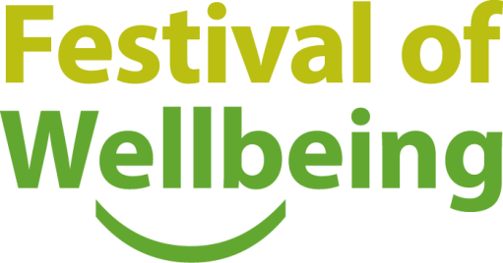

A key element in ensuring an environment for work that is inter- inclusive, and supportive of all is recognising the importance of the wellbeing of all its staff in the workplace. Launched at the two-week Festival of Wellbeing in June 2017, and part of the People Strategy, WellCAM is a comprehensive approach to health and wellbeing of staff supported by a new website and the University Wellbeing Champion, Dr Nick Bampos.

The Festival continued its focus on raising awareness of issues associated with mental and physical wellbeing for the University as an employer and its staff. This encapsulates the University’s work on the promotion of health and prevention of work-related stress. It is widely acknowledged that issues of health, wellbeing and engagement are likely to become increasingly significant over the next decade or two, due to demographic changes within the workforce.

### Promoting a culture of positive awareness of disability

The University aims to encourage increased levels of disability disclosure by promoting a culture of positive awareness and understanding of disability-related matters. Data presented in this report shows that only 2.2% University of Cambridge staff have disclosed a disability[11]. 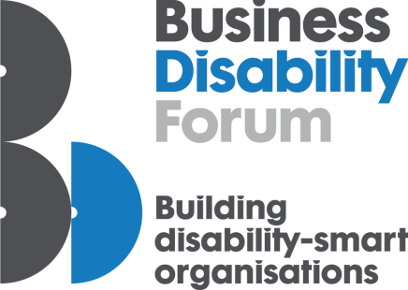Disclosure of sensitive information is encouraged either at application, start of employment or during employment. The University understands that self-disclosure is a personal choice and that not all employees wish to disclose their disability status but providing data supports the institution’s analysis of recruitment, progression and representation, from which actions can be initiated to address any concerns regarding discrimination or unfairness.

To support this goal, E&D began a review of current support provision for disabled staff during 2016-17 and joined the specialist Business Disability Forum[12] to advise on changes that could be made to improve the physical and mental wellbeing of staff. The E&D Strategy includes the aim of reframing and relaunching focussed networking and engagement activity in this area in 2018.

In regards to disclosure beyond disability, the University has been providing an opportunity for staff to disclose information on sexual orientation and religion or belief through the Employee Self Service system (ESS) since 2012 in line with the request by the Higher Education Statistics Agency (HESA). This combined with the University’s new online recruitment system has enabled more comprehensive collection of diversity information for all staff with a steady increase of voluntary disclosure rates for personal information. With regard to transgender staff, numbers disclosed remain too small to publish but continue to be monitored internally.

### Ensuring an inclusive environment for study

The University is dedicated to creating and maintaining a safe, welcoming, inclusive and diverse community which nurtures a healthy environment and culture of mutual respect and consideration, allowing all members to thrive without fear of sexual violence, abuse, coercive behaviours or related misconduct.

The Office for Student Conduct, Complaints and Appeals was formed last year, with specialist staff who deal with student complaints centrally in the University[13]. It oversees a new complaints procedure where students can request that other student behaviour is investigated without having to go through the University’s formal discipline procedure.  These procedures deal with student complaints, requests for examination review, and reviews of decisions taken regarding individual student applications under existing procedures; for example exam allowances under the Applications Committee, alternative modes of assessment under the Board of Examinations and additional attempts at professional examinations under a Faculty Board. The changes proposed in the Report included the development of new and simplified procedures to ensure compliance with the Office of the Independent Adjudicator’s (*OIA*) Good Practice Framework. Each procedure includes explicit timeframes for each stage and clearly explains what students can expect.

In April 2017, the General Board and the Council approved a Joint Report for the *Procedure for Handling Cases of Student Harassment and Sexual Misconduct*, which includes a code of conduct for students.  New webpages promote these procedures and provide guidance for students and student-facing staff.Staff have been offered a briefing session, delivered in partnership with Rape Crisis, to ensure they are appropriately handling student disclosures of sexual violence.

As part of the University’s commitment to provide a safe environment for our students an anonymous reporting tool was been introduced in April 2017 to give students and staff another choice in how they can report a sexual harassment incident.  This option also enables the University to monitor the number and type of reports and the reasons why those reporting wished to remain anonymous. A newly created post at the Student Counselling Service, University Sexual Assault and Harassment Advisor, will also provide support and advise students who have been subjected to harassment or sexual assault.

In addition, a collaborative project on preventative actions, match-funded by HEFCE, involves CUSU, the GU, the Sports Service, E&D, the Office of Student Conduct, Complaints and Appeals (*OSCCA*), the Student Counselling Service and the Colleges. The project trials and evaluates a number of initiatives including an online training package on consent; consent workshops; a bystander programme (with Colleges); training for College and University staff by Rape Crisis; and work with sports clubs on gender issues.Evaluation of the initiatives is being undertaken by the student group, The Cambridge Hub, and will be completed by May 2018.

The University has produced a statement on harassment and sexual misconduct, as well as guidance for consensual student-staff relationships. It continues to work on better procedures for handling staff-student/student-staff harassment and sexual misconduct.

## Objective 5: Building Engagement and Best Practice

**To increase engagement in equality, diversity and inclusive best practice across the collegiate University through participation in training, learning opportunities, joint working and shared objective**

A key focus of the collegiate University’s work on increasing engagement and developing best practice has been the development of a programme on unconscious bias (UB) training. Unconscious bias training is widely recognised as an effective method to increase awareness and improve practice. During 2016-17 the University developed and released an Understanding Unconscious Implicit Bias online course[14]. Accessible by all staff of the collegiate University, this provision has been supported by additional resources to support the mitigation of bias within the University including the delivery of equivalent face-to-face UB training across Schools and Colleges, supplementary seminars and specialist workshops.

The UB training builds on the University’s continued focus on embedding best practice and knowledge via completion of the E&D Essentials online training module. Completions across the University had risen to 74% of all staff, with many Schools making it mandatory for all those involved in staff appointments to have completed the training. The E&D team, through their Schools’ Liaison function works with Schools, Departments and Colleges to share best practice and advise of a range of matters including recruitment best practice and setting up local level E&D committees and forums.

### Diversity networks

Diversity networks are an internal resource to assist the University in engaging and understanding the needs of different groups. The following Networks are supported by the University's Equality Champions and represented on the E&D Committee:

* Disabled Staff Network
* LGB&T Network
* Women’s Staff Network
* SPACE Network

The networks, open to University, College or an associated institution, play an important role in hosting a number of key internal diversity events. The University’s Annual Race Lecture in October 2016 was on the topic of “Race, Representation and Visibility”. It brought together eminent speakers: Professor Laura Serrant, a patron of the Race Equality Charter for Higher Education , Anwar Uddin, Diversity and Campaigns Manager for the Football Supporters’ Federation (FSF) and Dr Sandie Okoro, General Counsel of HSBC Global Asset Management and member of the Equality Standards Panel of the Premier League.

The 13th Annual Disability Lecture – “The Power of Design: Inclusion or Exclusion?” with speaker Dr Sue Kroeger investigated how organisations can translate the theory of inclusive design into a pragmatic reality.

The Women’s Staff Network, with membership from all staff groups across the collegiate University, focussed on providing accessible self-development opportunities. The Women’s Staff Network held workshops and seminars for women on topics including how to have difficult conversations with peers or others in or outside the workplace and building resilience in the workplace. The WSN also hosted ‘Mind the Gap’ – a presentation by Dr Alison Parken on the drivers of gender pay gap and a summary of the University’s Equal Pay Review results for 2016.

The LGBT History Month Lecture ‘Being Out and LGBT+ Today’ was a panel discussion with Professor Elena Rodriguez Falcon from the University of Sheffield and the LGBT UK Leaders & Advocates Powerlist. Other events considered best practice on LGBTQ inclusivity in the higher education curriculum.

While the University does not run a network for staff religion and belief, Faith and Belief in Practice is a three-way partnership project between the University, Trinity College and Great St Mary’s Church that seeks to increase awareness and understanding of religious and belief communities in the University. The work is overseen by the Chaplaincy Development Group, a partnership between the University, Great St. Mary's and the Trinity College.

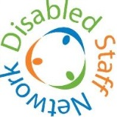

### Equality Assurance Assessments

To further embed best practice across the University, an Equality Assurance Assessment (EAA) process has been established that ensures the University meets its equality duties to show due regard to protected groups, as set out within the Equality Act 2010. This allows identification and consideration of equality impact when developing or reviewing relevant and proportionate policies or functions. By using this evidence-based approach, the University is able to make informed decisions to eliminate disadvantage and promote equality of opportunity. In 2016-17, 7 EAAs were commenced of which 1 EAA was fully concluded. These are recorded on the EAA schedule (Appendix 2). The Schedule is governed by the EAA Review Group on behalf of the E&D Committee.

# Part Two – Key Facts and Figures

## 1 Staff Key facts and figures

**This section presents equality and diversity information for the academic year 2016-17 at the University of Cambridge for staff and students. Please refer to the notes and definitions in Appendix 1 for a detailed explanation of the data provided.**

At 31 July 2017, the University had 11,807 employees in four University staff groups (Table 1).

|  |  |  |
| --- | --- | --- |
| **Staff Group** | **Number of employees (headcount)** | **Percentage of employees** |
| Academic | 1,753 | 14.8% |
| Academic-Related | 2,125 | 18.0% |
| Assistant | 3,814 | 32.3% |
| Researcher | 4,115 | 34.9% |
| Total | 11,807 | 100.0% |

Table 1 Count by staff group

* The gender breakdown in the University was 50.1% (5,918) female and 49.9% (5,889) male (Figure 1).
* 84.1% (9,929) employees had a known disclosed ethnic background. Of these staff, 12.4% (1,234) were Black and Minority Ethnic (BME), 28.0% White - Other and 59.6% White – British (2,553 and 6,142 respectively).
* 2.2% (263) of all employees disclosed having a disability
* The University now holds sexual orientation information for 43.9% of all staff. 5.8% of staff who declared their sexual orientation were LGB.
* The University now holds religion and belief information for 43.8% of all staff. 34.4% of staff who declared their religious beliefs were Christian and 57.2% had no religion.

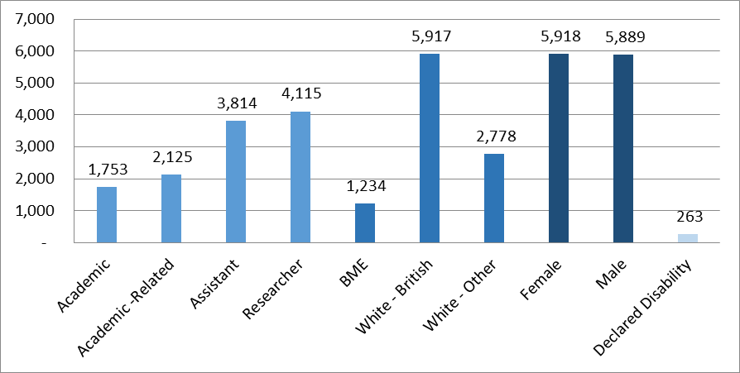

Figure 1: Headcount and diversity summary as at 31 July 2017

## 1.1 Gender

### 

### Staff groups and grades

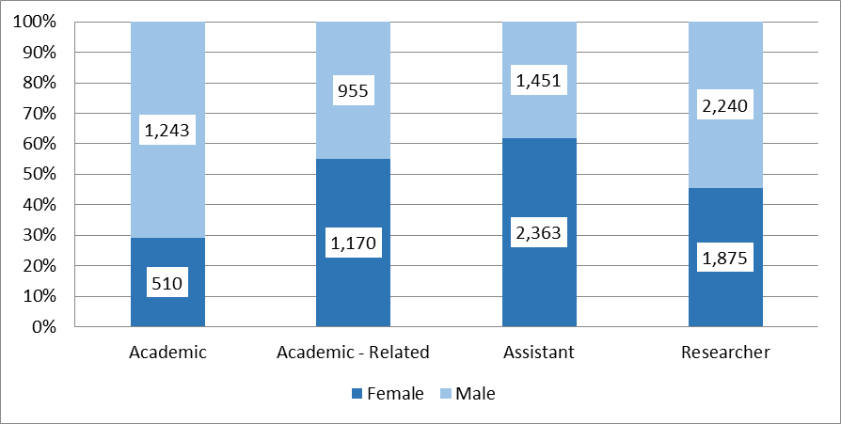

Figure 2: Gender breakdown by staff group

Figure 2 shows the number and proportion of women and men in each of the University’s four staff groups. Women comprised 29.1% of Academic staff and 62.0% (2,363) of Assistant staff.

25.9% of all staff were employed on Grade 7. The percentage of female employees in each grade increases from 55.4% (237) at Grade 1 up to 72.1% (662) at Grade 4 and then decreases through the remaining grades to 19.0% (145) at the Grade 12 (Figure 3). The high percentage of female employees at Grade 4 corresponds with the high percentage of Assistant staff who are female.

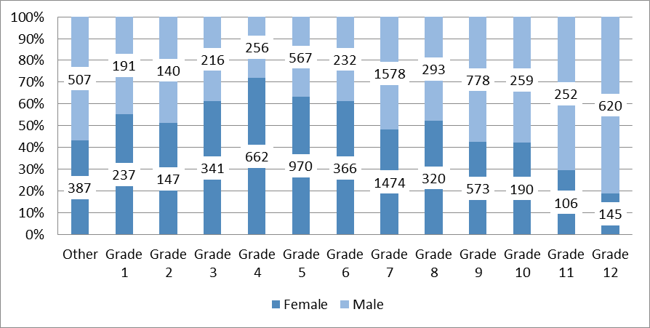

Figure 3: Gender breakdown by grade

### 

### Academic staff type

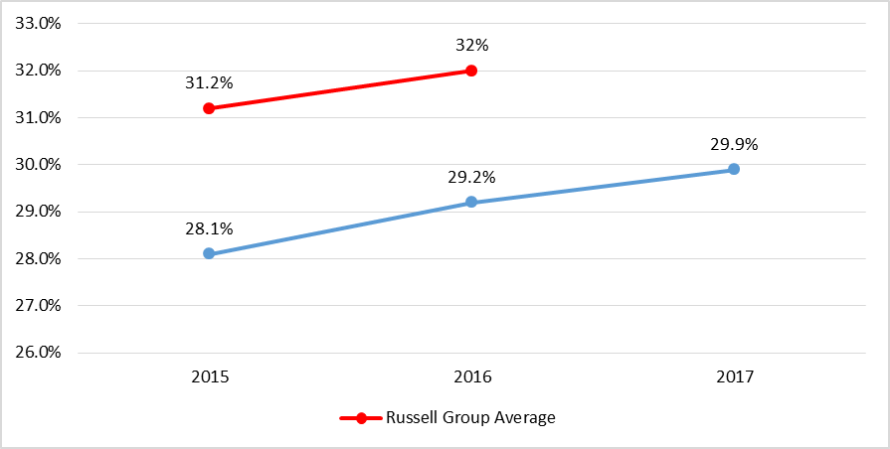

Figure 4 Proportion of Academic staff who were female, University of Cambridge 2015-17 and Russell Group average (2014/15 and 2015/16 data)

In July 2017 29.1% of Academic staff at the University were female, with no change from the previous year and below the average percentage for Russell Group institutions (Figure 4). They represented 36.4% of University lecturers, 35.1% of Senior Lecturers and 27.8% of Readers. 18.0% of professors were female (Figure 5).

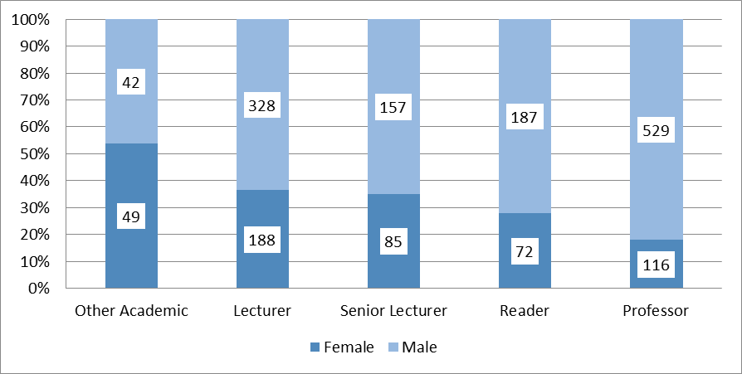

Figure 5: Gender breakdown of Academic staff 2017

Since 2015 the University has seen a gradual rise in the proportion of women within each of the Academic positions, with the exception of Senior Lecturer which decreased as staff have been promoted (Figure 6).

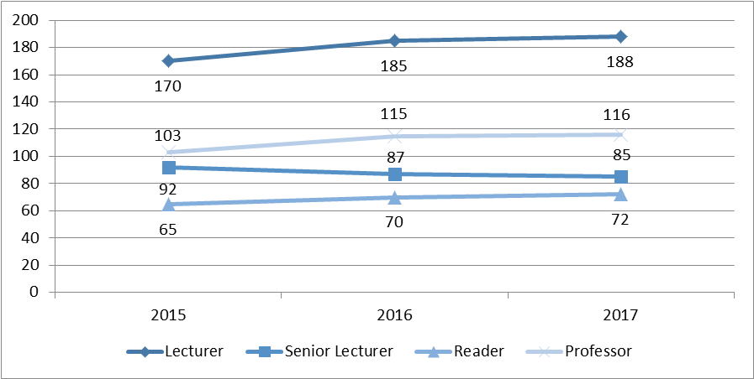

Figure 6 Number of Academic staff who were female by position, University of Cambridge 2015-17

The University had 116 female Professors in 2017, with the proportion of Professorships held by women at 18.3%, below the Russell Group average (Figure 7).

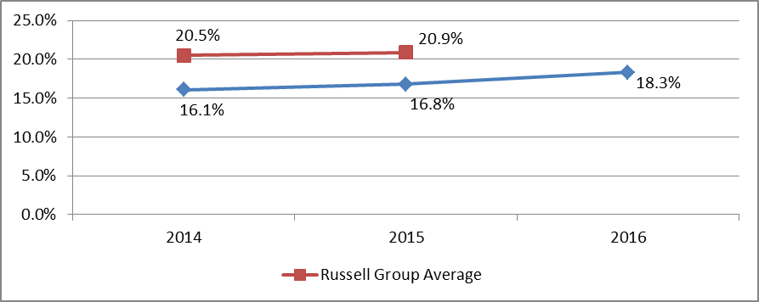

Figure 7 Proportion of Professors who were female, University of Cambridge 2014-16 and Russell Group average (2014/15 and 2015/16 data)

### STEMM vs AHSSBL

Female staff comprise 46.9% (3,400) and 51.6% (1,028) of all STEMM and AHSSBL staff respectively (Figure 8). Female Academics in STEMM and AHSSBL comprise 22.6% (228) and 37.9% (278) of Academic staff respectively.

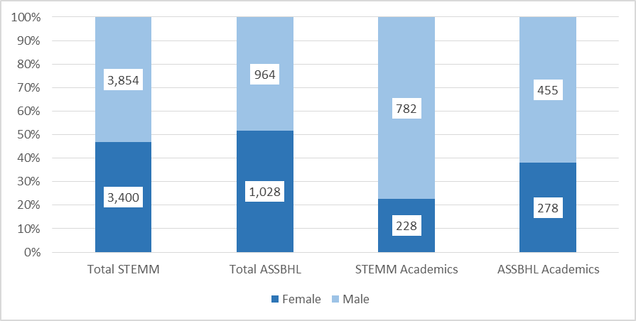

Figure 8 Overall STEMM vs AHSS as well as Academics by gender

### Employment status

Fixed term contracts make up 29.8% (3,518) of all contracts at the University. 29.0% (1,717) of all female staff are on a fixed term contract compared to 30.6% (1,801) of men. 52.1% and 57.1% of female and male Research staff, respectively, were on fixed term contracts. The Researcher staff group was comprised of 45.6% women. Overall, 19.8% (2,339) of all employees were part-time, with female employees at 29.2% (1,734) compared to 10.3% (605) of male employees. 93.7% (1,165) of male Academics were on established contracts with 86.1% (439) of female Academics on established contracts (Figure 9).

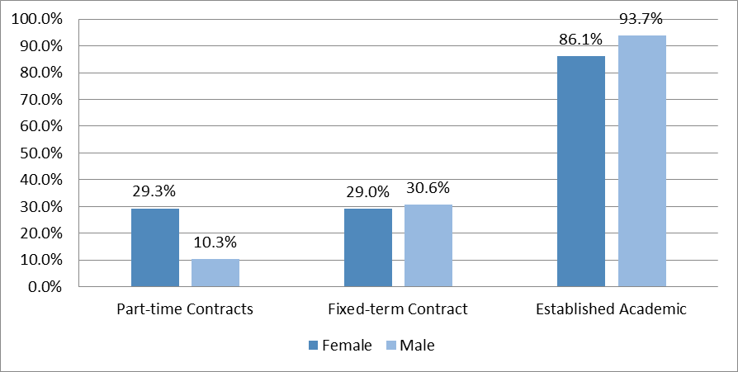

Figure 9 Employment status by gender

### University Committees and Governance

In 2016/17 the University Councils of Schools and influential main committees had a total of 222 occupied positions; several roles are taken up by the same person or are currently vacant. 30.6% (68) of members are female staff. Female staff make up 42.3% (11) of the Council, which is the largest committee and the principal executive and policy-making body of the University (Table 2). Figure 10 demonstrates the gender breakdown across the senior administration of the University.

Table 2 Percentage of female members on influential University committees and Councils of Schools[15]

|  |  |  |  |
| --- | --- | --- | --- |
| **Committees** | | **Councils of Schools** | |
| Audit Committee | 40.0% | Arts and Humanities | 33.3% |
| Board of Scrutiny | 25.0% | Biological Sciences | 23.8% |
| Council | 42.3% | Clinical Medicine | 23.1% |
| Finance Committee | 27.8% | Humanities and Social Sciences | 28.6% |
| General Board of the Faculties | 31.3% | Physical Sciences | 16.7% |
| Planning and Resources Committee | 30.0% | Technology | 19.0% |
| Resource Management Committee | 17.0% |
| Human Resources Committee | 57.1% |  |  |
| E&D Committee | 61.9% |  |  |

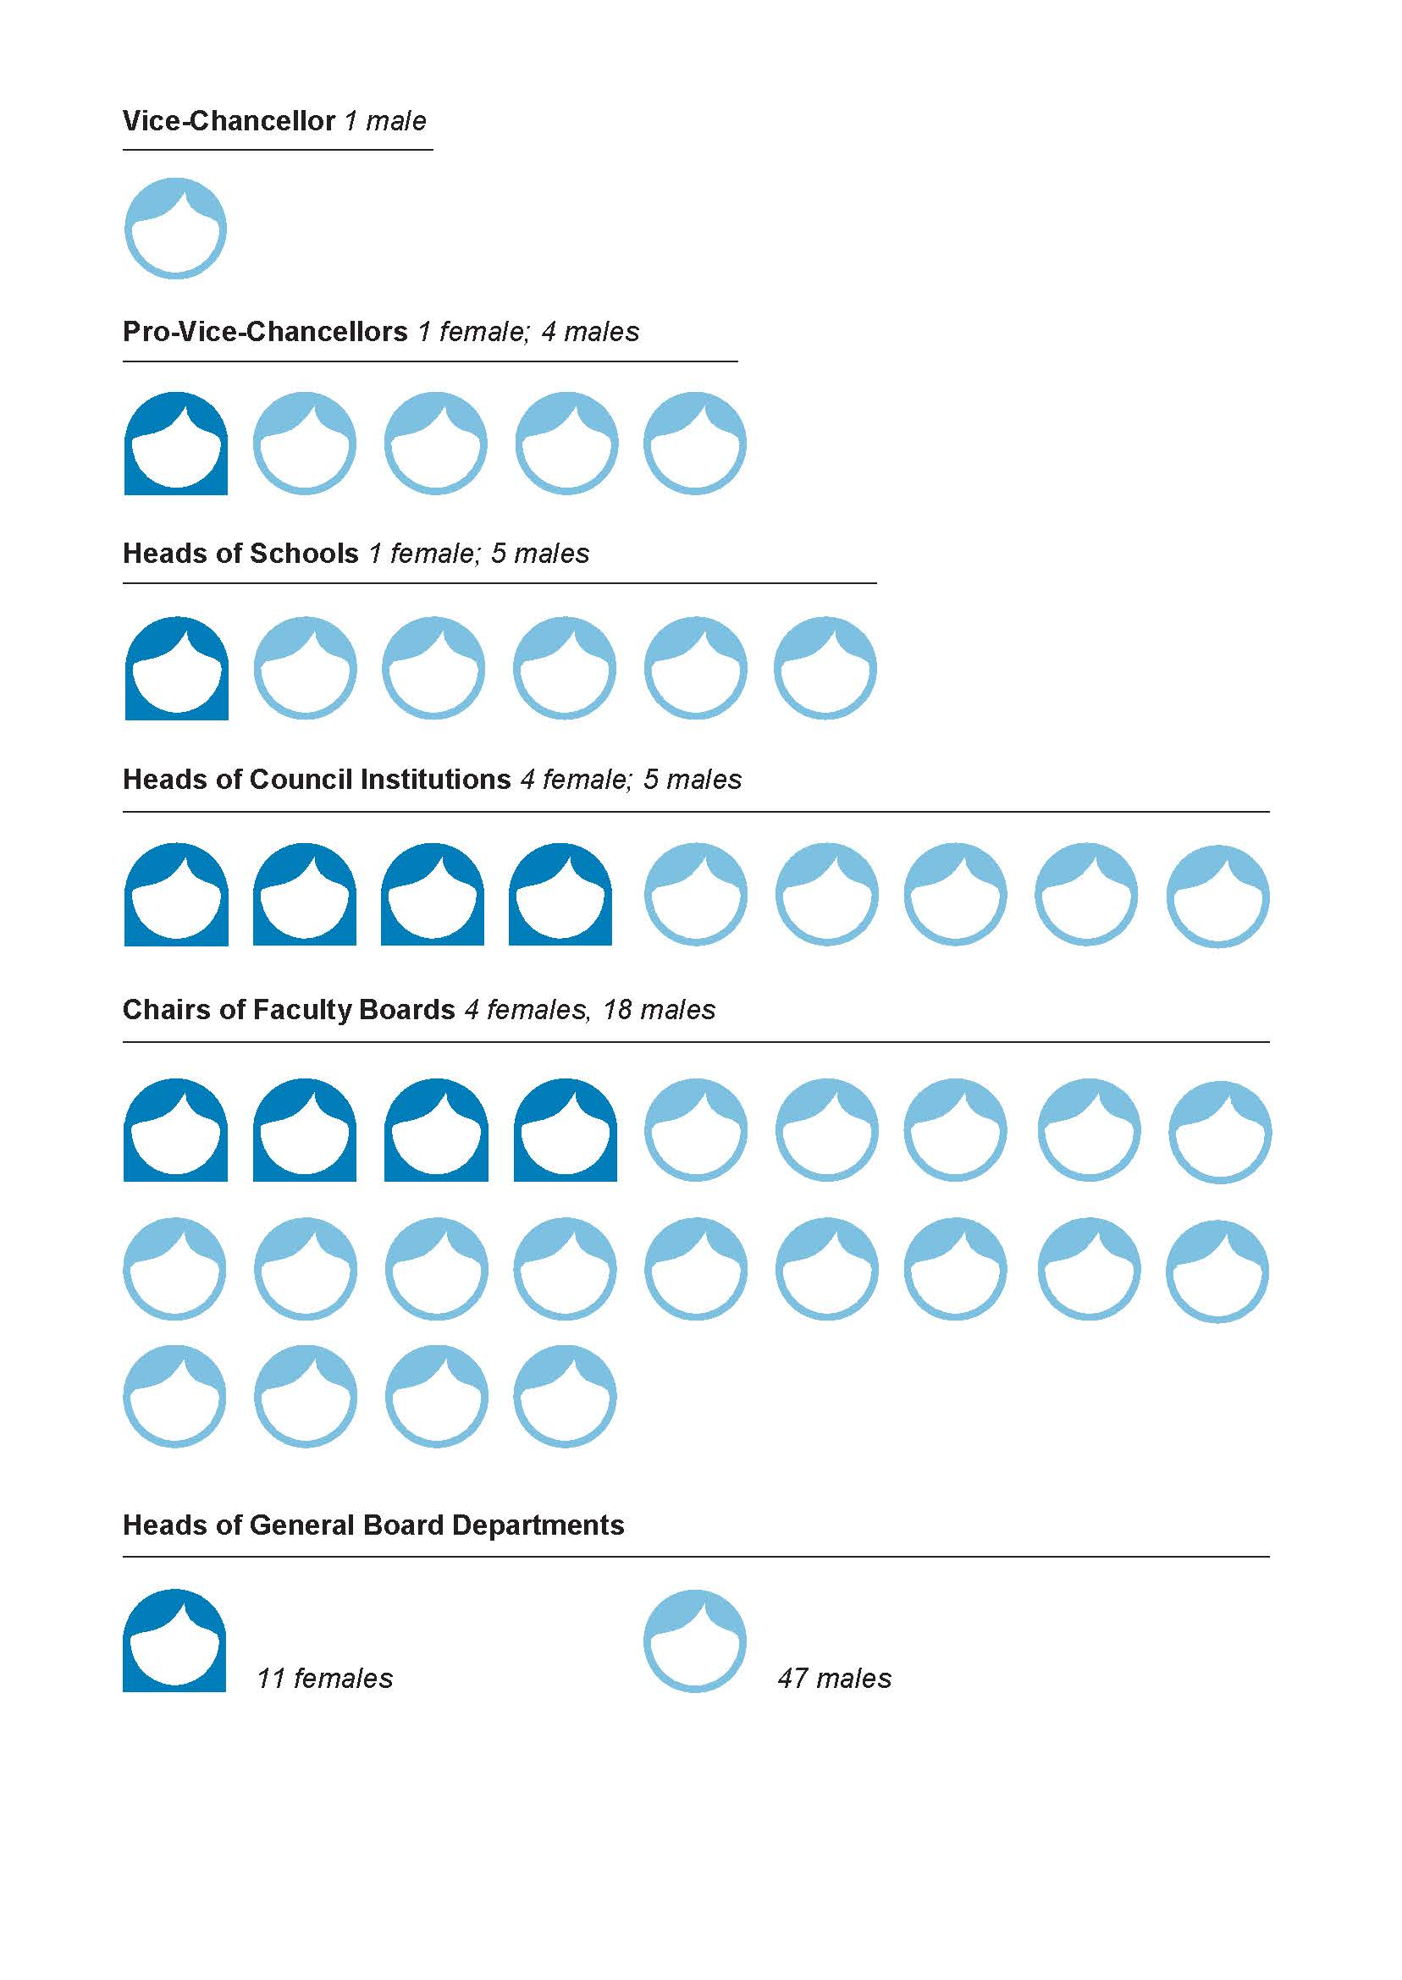

Figure 10 Pyramid of power

## 1.2 Ethnicity and Nationality

### Ethnic Groups employed

The University employees staff from a variety of ethnicities represented in Table 3.

|  |  |  |
| --- | --- | --- |
| Ethnicity | Count | %* |
| Arab | 26 | 0.3% |
| Asian or Asian British - Bangladeshi | 15 | 0.2% |
| Asian or Asian British - Indian | 260 | 2.6% |
| Asian or Asian British - Pakistani | 31 | 0.3% |
| Black or Black British African | 52 | 0.5% |
| Black or Black British Caribbean | 18 | 0.2% |
| Chinese | 377 | 3.8% |
| Mixed Ethnicity | 185 | 1.9% |
| Other Asian Background | 197 | 2.0% |
| Other Black Background | 11 | 0.1% |
| Other ethnic background | 62 | 0.6% |
| White - British | 6,142 | 61.9% |
| White - Other | 2,553 | 25.7% |
| Unknown | 1,878 | * % of total, excluding unknowns |
| **Total** | **11,807** |

Table 3 Ethnicity count

Overall, of the 84.1% who disclosed their ethnicity, 12.4% were BME (1,123; Figure 11). The largest BME group represented were Chinese who accounted for 3.8% (377) of those who disclosed their ethnicity.

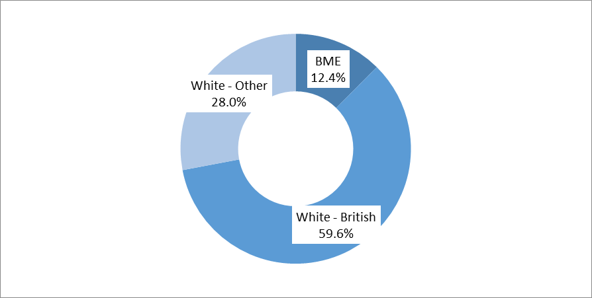

Figure 11 BME, White - Other, White - British pie chart

The proportion of staff who have declared they are BME has risen over the last three years (Figure 12).

Figure 12 Proportion of staff who were BME, University of Cambridge 2014-16 and Russell Group average (2013/14 and 2014/15 data)

### Nationality

Staff from 117 countries were employed by the University of Cambridge in 2017. Non-UK nationalities made up 34.7% (3,717) of the University staff population with known nationality (Figure 13). The University did not hold nationality data for 9.2% of staff.

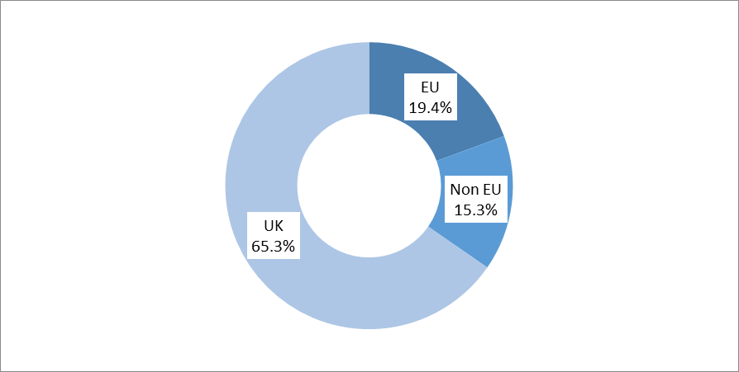

Figure 13: Nationality of University staff 2017

### Staff groups and grades

The Researcher group contains the highest proportion of BME (21.9%; 699) and White Other (43.0%; 1,374). Assistant staff were more likely to be White-British (75.8%; 2,538) (Figure 14).

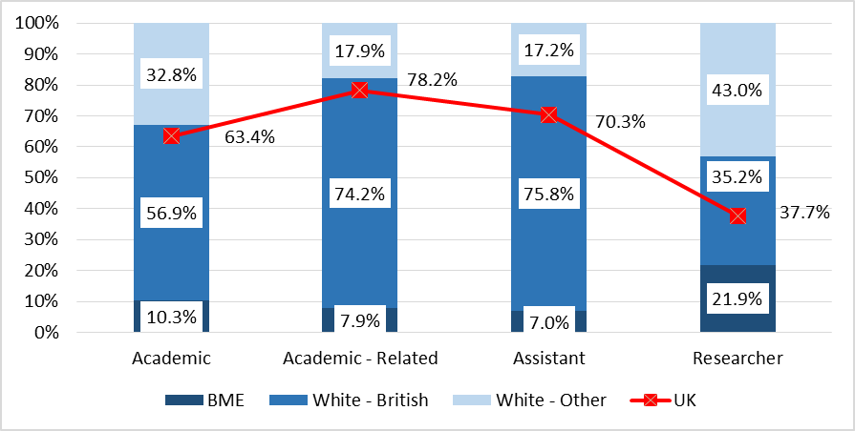

Figure 14 Staff groups by known ethnicity and nationality

The percentage of Academic staff who declared that they were of Black or Minority Ethnic ethnicity has continued to rise over the last three years (Figure 15).

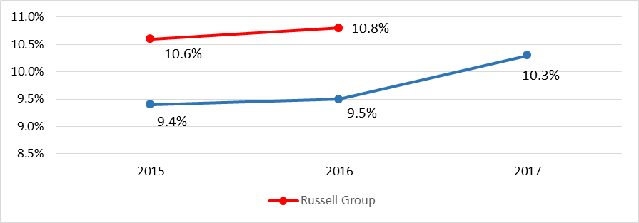

**Figure 15 Proportion of Academic staff who were BME, University of Cambridge 2014-16 and Russell Group average (2014/15 and 2015/16 data)**

### Employment status

492 (39.9%) BME staff were on a fixed term contract compared to their White - British counterparts for whom 20.3% (1,199) of contracts are fixed term – a reflection of the proportion of BME staff who have Researcher positions. There appeared to be little difference in the percentage who were Established Academics (Figure 16).

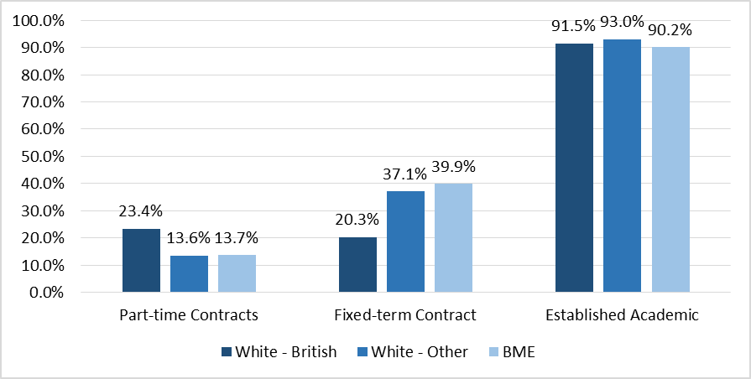

Figure 16 Contract type by ethnicity

## 1.3 Disability

The University held disability information on 78.1% of staff, with 2.2% (263) disclosing they had a disability. 30.8% (81) of those who disclosed a disability were categorised as having a Specific learning difficulty such as dyslexia, dyspraxia or AD(H)D (Table 4). The University’s percentage of staff who have declared a disability continues to sit below the Russell Group average, which was 3.8% in 2015/16. The average figure in HE of disabled staff is 4.7% (2014/5 HESA), and it is estimated that there are 13.3 million disabled people in the UK, of which 18% are of working age.



Table 4 Disability categories of staff who disclosed a disability in 2017

## 1.4 Age

The median age of staff at the University on 31 July 2017 was 40 years with a mean of 42, unchanged since last year. The percentage of female staff represented in age groups decreases as the age increases (Figure 17).

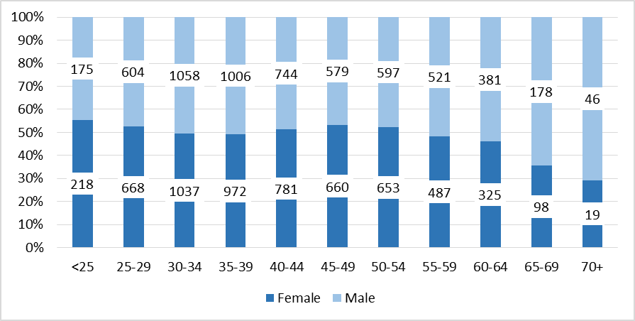

Figure 17 Age by gender

## 

## 1.5 Sexual Orientation and Gender reassignment

In 2017 the University held sexual orientation data for 43.9% (5,189) of the employee population. Of this 5.8% (303) identified as lesbian, gay, bisexual or other (Figure 18). As disclosure rates continue to increase more detailed analysis will be undertaken.

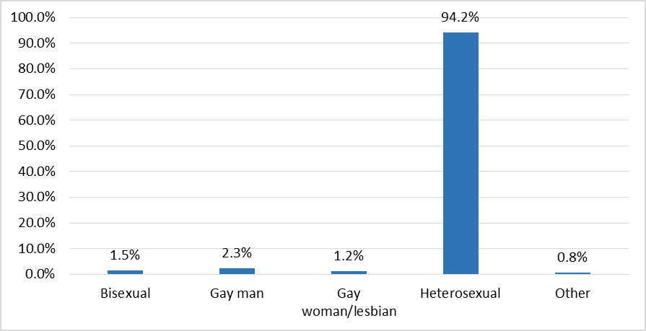

Figure 18 Disclosed sexual orientation of staff 2017

The University does hold information disclosed by staff regarding gender reassignment but this will not be published due to issues of low disclosure rates and confidentiality.

## 1.6 Religion or Belief

Data for Religion or Belief was held for 43.8% of University staff in 2017. For staff who have disclosed their religious beliefs, 57.2% (2,954) have selected ‘no religion’ with the next highest group at 34.4% (1,778) selecting ‘Christian’ with the remaining 7 selections adding up to 8.4% (Figure 20). As with sexual orientation, it is anticipated that as disclosure rates increase such more detailed analysis can be undertaken.

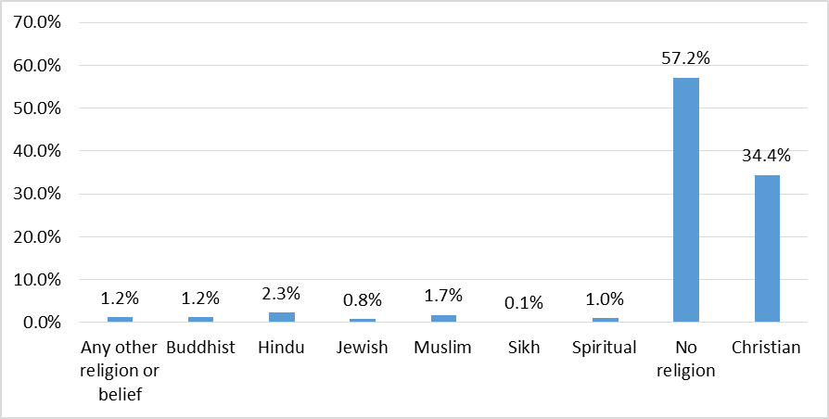

Figure 19: Disclosed religion and belief of staff 2017

## 2 Student Key facts and figures

**This section presents equality and diversity information for the academic year 2016-17 at the University of Cambridge for staff and students. Please refer to the notes and definitions in Appendix 1 for a detailed explanation of the data provided.**

The following information is a summary of student figures sourced from the University’s Student Statistics Office. Comparative data are sourced from HESA via the Higher Education Information Database for Institutions. In addition to the University wide data detailed below, the General Board’s Learning and Teaching Reviews[16] provide a further opportunity for student data to be interrogated at the Faculty and Departmental level as they relate to the protected characteristics.

## 2.1 Gender

### Student Numbers by gender

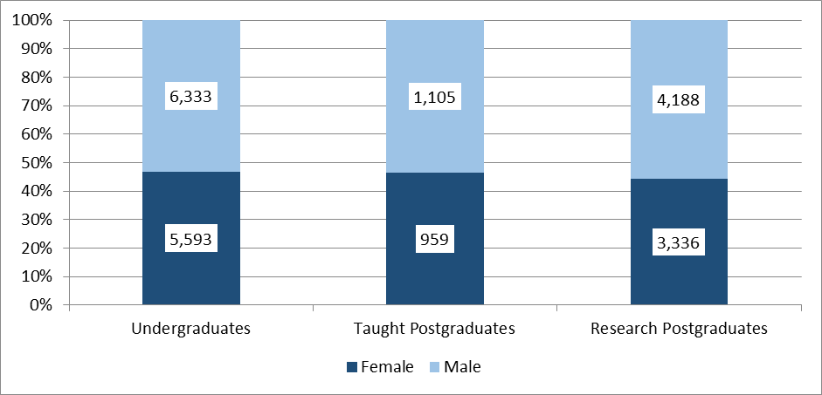

**Figure 20 Student numbers by gender 2016-17**

In 2016-17, female students comprised 46.3% of all undergraduate students and 46.4% of all taught postgraduate students (PGT) and 44.3% of all research postgraduate students (PGR) (Figure 20). These proportions have been consistent over a number of years at the University.

The percentage of female undergraduate students studying subjects in STEMM was 37.8%, an increase from 2014-15 (36.9%), compared with 59.1% studying Arts and Humanities subjects (Figure 21). Although Cambridge continues to sit below the 48.1% Russell Group STEMM benchmark (HESA 2015-16 data), significant work has been committed to programmes such as Athena SWAN and departmental initiatives to seek to encourage female participation in STEMM subjects.

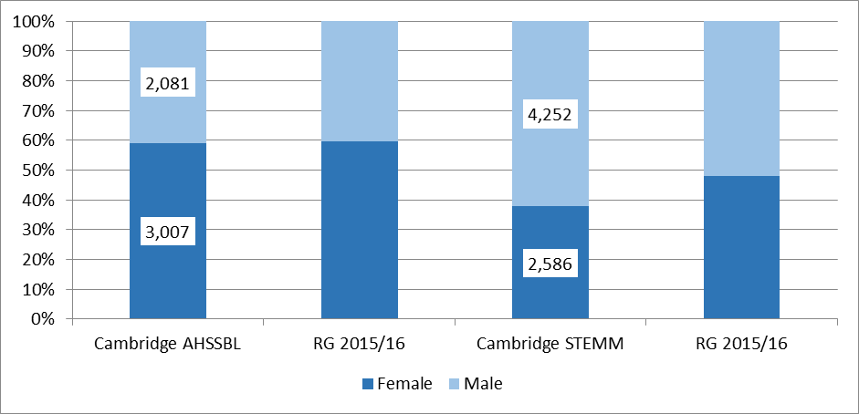

Figure 21 Undergraduate student numbers by subject and gender (2016-17) with Russell Group 2015-16 (HESA data) benchmark

### Undergraduate Admissions by gender

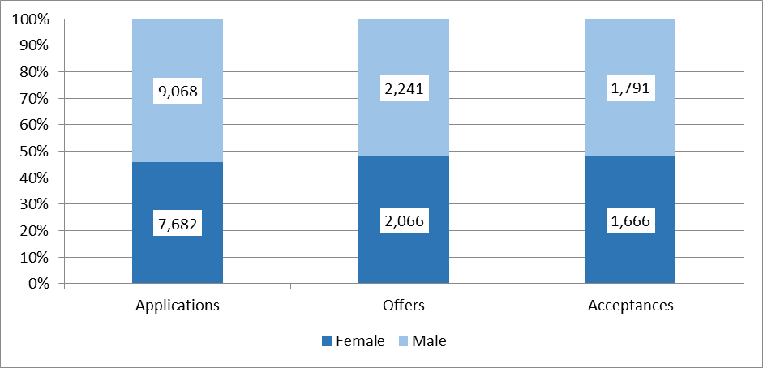

**Figure 22 All undergraduate admissions by gender (October 2016)**

In 2016 there were fewer applications to the University from prospective students who were female (45.9%). However, female students were more likely to be offered places, making up 48.2% of all admissions (Figure 22).

### Graduate Admissions by gender

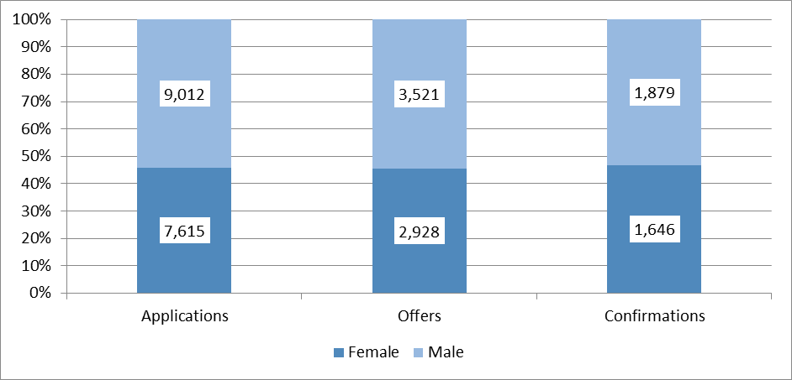

Figure 23 Graduate admissions by gender (2016-17)

In 2016-17 applications were received from 9,012 males and 7,615 females (45.8% female) (Figure 23). 38.5% of female applicants were offered a place compared to 39.1% of male applicants.[17]

### Undergraduate degree attainment by gender

|  |  |  |  |
| --- | --- | --- | --- |
|  | **Class I** | **Class II Division I** | **Class II Division II and lower** |
| **Men** | 26.3% | 43.1% | 30.6% |
| **Women** | 19.8% | 50.4% | 29.8% |

Table 5 UK domiciled students - undergraduate examination results by gender 2017.

The percentage of women gaining first class examination results was 19.8% compared with 26.3% of males, a gender attainment gap of 6.5% (Table 5). This gender gap was reversed for ‘good degrees’ with 70.2% of women and 69.4% of men receiving an examination classification of 2:1 or above. Internal research has indicated that gender gaps can be apparent over a range of disciplines and not restricted to disciplines with low proportions of female students. Gender attainment gaps continued to be source of attention for GBEC’s E&D Standing Committee in 2016-17.

## 2.2 Ethnicity

### **2.2.1 Undergraduate Admissions by ethnicity**

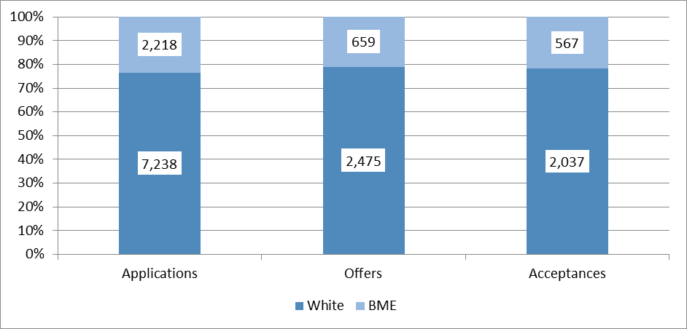

**Figure 24 Home undergraduate admissions by ethnicity (October 2016)**

Students from a BME background comprised 23.5% of home undergraduate applicants, up from 21.9%in 2015. 21.0% of all offers and 21.8% of all students who accepted a place in 2016-17 were BME (Figure 24).

### Student numbers

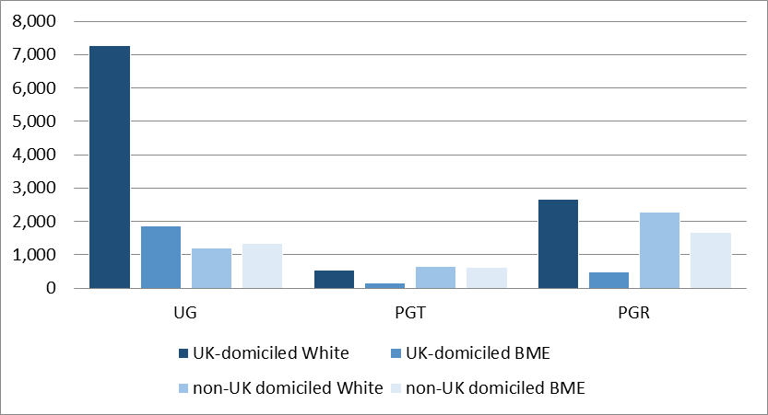

**Figure 25** **All student numbers by known ethnicity and domicile – disclosed ethnicity (2016-17)**

Figure 25 shows that students from a BME background made up 27.5% of all undergraduate students who disclosed their ethnicity – 20.4% of UK domiciled UG students and 52.9% of non-UK domiciled UG students. The majority of UG BME students were UK domiciled (58.2%).

39.1% of Taught postgraduates (21.8% UK domiciled PGT) and 30.3% of Research postgraduate students (15.1% UK domiciled PGR) in 2016-17.

### Graduate Admissions by ethnicity

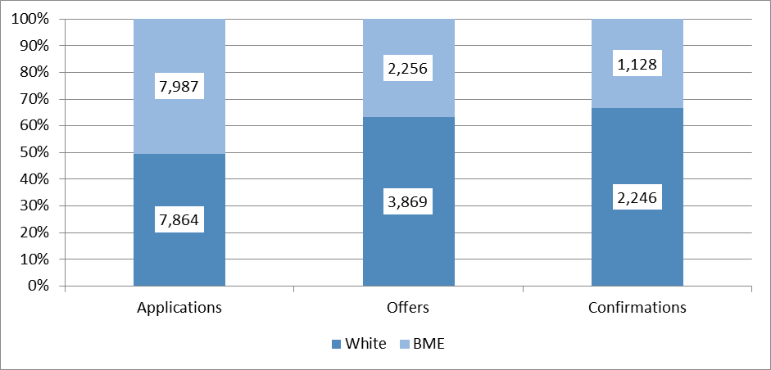

Figure 26 Total graduate admissions by ethnicity 2016-17

In 2016-17 applications were received from 7,864 White and 7,987 BME students (48.0% of all applicants) (Figure 26). Of those who accepted offers from the University, 1,128 were BME and 2,246 were White (32.0% BME).

### Undergraduate degree attainment by ethnicity

|  |  |  |  |
| --- | --- | --- | --- |
|  | **Class I** | **Class II Division I** | **Class II Division II and lower** |
| **White** | 24.1% | 47.1% | 28.8% |
| **BME** | 19.5% | 44.8% | 35.7% |

Table 6 UK domiciled students - undergraduate examination results by ethnicity 2016-17

The percentage of White students gaining first class examination results was 24.1% compared with 19.5% of BME students, an ethnicity attainment gap of 4.6% (Table 6). This gap increased for ‘good degrees’ with 71.2% of BME and 64.3% of White students receiving an examination classification of 2:1 or above. Please see Objective 3 about work the University is undertaking in this area as internal research has indicated variation by ethnicity in terms of attainment.

## 2.3 Disability

### Undergraduate Admissions by disability

There were 1,038 applicants with a declared disability (6.2% of all undergraduate student applicants); of these 275 were accepted (6.4% of total undergraduate acceptances). Almost 35% of those students declaring a disability accepted into the University disclosed a ‘Specific learning disability’ (such as dyslexia). Disclosure of disability tends to increase post admission, with the DRC reporting that 35-40% of the students on their records disclosed after being admitted.

### Student numbers

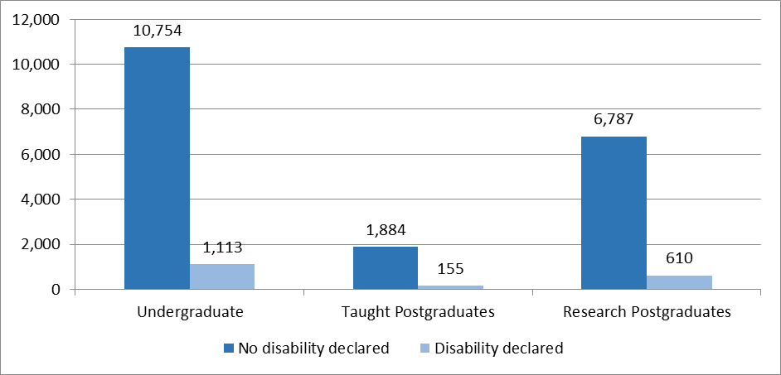

**Figure 27 Student numbers by disability status (2016-17)**

1,113 Undergraduates and 155 Taught and 610 Research graduates (equating to 9.3%, 7.5% and 8.1% respectively) disclosed a disability in 2016-17 (Figure 27). Of these students 684 disclosed a Specific Learning Difficulty, representing 36.4% of all disabled students. This reflects an increase in the proportion of undergraduate students who have reported a disability since 2015-16 (8.4%, 5.2% and 5.4% respectively).

Please note that the figures above reflect the number of students who disclosed at matriculation. These numbers rise during the year with the DRC reporting the total number of disabled students at 2,410 at the end of 2016-17[18].

### Graduate Admissions by disability

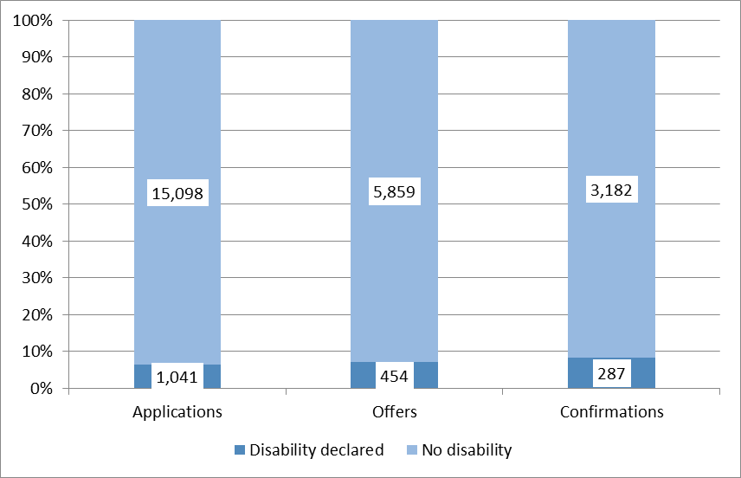

Figure 29 Graduate admissions by declared disability

In 2016-17 applications were received from 1,041 students with a declared disability (6.3% of total student applications (Figure 29)). Of those who accepted offers from the University, 287 were disabled. The success rates for students receiving offers was 43.6% and 38.9% for those who had declared a disability and those without a disability, respectively.

### Undergraduate degree attainment by disability

|  |  |  |  |
| --- | --- | --- | --- |
|  | **Class I** | **Class II Division I** | **Class II Division II and lower** |
| **No Disability** | 23.5% | 46.3% | 30.1% |
| **Declared Disability** | 20.5% | 48.5% | 31.1% |

Table 7 UK domiciled students - undergraduate examination results by disability 2017

Table 7 shows that the percentage of students with no declared disability gaining first class examination results was 23.5% compared with 20.5% of students who declared a disability, an attainment gap of 3.0%. This gap reduced for ‘good degrees’ with 69.9% of non-disabled and 68.9% of disabled students receiving an examination classification of 2:1 or above. Analysis of this data to a more granular level is complicated by small numbers.

# Appendix 1

## Staff - Definitions and notes

This E&D Information Report is derived from the HR CHRIS[19] system at a 31 July 2017 census date.

Any person who holds a University office or post and has a University contract of employment is considered to be an employee. Employees are categorised as Academic, Academic-related, Assistant or Researcher on the basis of the main duties of their post.

The staff numbers presented are of individual staff members (headcount) rather than full time equivalent (FTE). Full-time staff are defined for the purpose of this report as being employed at 1 FTE (full-time equivalent). Part-time staff are defined as being employed at less than 1 FTE.

Established Academic and Academic-related staff hold University Offices as defined in the Statutes and Ordinances of the University of Cambridge[20]. Unestablished staff are those Academic and Academic-related staff who do not hold University Offices or are in Research positions. Academic roles are further disaggregated into Academic staff type, namely University Lecturer, Senior Lecturer, Reader and Professor.

Where staff had multiple contracts or in cases where contracts involve more than one activity, a set rule was applied for non-Academic staff. The individual was assigned to the position with the highest FTE, or if the FTEs were identical, the staff member was assigned to the position that they had held for the longest period of time. In cases where Academic staff held both an Academic and Research post, they were assigned to their Academic role. Positions held in association with a substantive full-time appointment, including Associate Lectureships, Heads of Department and Chairs of Faculty Boards, were not counted. A number of University roles have been grouped into the category ‘Other’ as they have not been assigned to a specific grade. This category includes staff employed in some Clinical roles, as Marie Curie Fellows, Special Appointments or those with blank records[21].

Each post is assigned to a specific grade within the grading structure 1–12[22]. The grades overlap with staff groups so members of different staff groups can be employed on the same grade, but with different core roles and responsibilities. Staff are defined as having either permanent (open-ended) or fixed contracts. Those on fixed contracts are employed for a fixed period or have an end date on their contract of employment.

Where staff information categories would include numbers of less than five, information has not been included in accordance with Higher Education Statistics Agency (HESA) policy in order to protect the confidentiality of individuals[23].

Due to rounding to one decimal place, some total percentages may not equal 100%. No statistical testing has been conducted due to the small number of staff in many of the categories and protected groups.

### Age (staff)

This report uses the following age categories:

– Under 25

– 25 to 29

– 30 to 34

– 35 to 39

– 40 to 44

– 45 to 49

– 50 to 54

– 55 to 59

– 60 to 64

– 65 to 69

– 70 and over

### Disability (staff)

Disability is recorded within the CHRIS system using the HESA staff categories[24]. HESA has a number of disability fields for staff disclosure at either recruitment or during employment at the University.

### Ethnicity (staff)

Some ethnicity data has been combined for easier comparison so that all Mixed Ethnicities (White and Asian, White and Black African , White and Black Caribbean and Other Mixed) are encompassed in Mixed Ethnicity. Historically only ‘White’ was recorded whereas the University now records White – British, White – Irish and White – Other as such for the purposes of this data, ‘White’ has been included within White – British

Ethnicity has been aggregated into these groups:

Arab

Asian or Asian British - Bangladeshi

Asian or Asian British - Indian

Asian or Asian British - Pakistani

Black or Black British African

Black or Black British Caribbean

Chinese

Mixed Ethnicity

Other Asian Background

Other Black Background

Other ethnic background

White - British

White – Other

### Arts, Humanities, Social Sciences, Business and Law Departments (AHSSBL)

This report uses a generic classification of academic departments from the HESA staff record. This is in line with the arts, humanities, social sciences, business and law (AHSSBL) departments covered by the Athena SWAN Charter (www.athenaswan.org.uk). At the University of Cambridge this includes employees in the following Schools: Schools of Arts and Humanities and Humanities and Social Sciences. It also includes the Judge Business School and affiliated Centres located in the School of Technology.

### Science, Technology, Engineering, Mathematics and Medicine Departments (STEMM)

This report uses a generic classification of academic departments from the HESA staff record. This is in line with STEMM departments covered by the Athena SWAN Charter (www.athenaswan.org.uk). At the University of Cambridge this includes employees in the following Schools: Biological Sciences, Clinical Medicine, Physical Sciences and Technology (with the exception of the Judge Business School and affiliated Centres).

### Benchmarking

Where useful, data from the other Russell Group universities has been provided for benchmarking purposes. These data have been sourced from HESA via the Higher Education Information Database for Institutions (HEIDI) online tool. The latest available information was for 2015-16 year.

## **Students - Definitions and notes**

The enclosed student figures are a summary of information sourced from reports and publications produced by the Student Statistics Office, Graduate Admissions and Cambridge Admissions Office. Further detailed information for all students is available from these sections. The information has been presented in line with the requirements of the Equality Act 2010 public sector equality duty which obliges higher education institutions to publish information about the people affected by its policies and practices; in this case students. No significance testing has been performed due to the low numbers of students in many of the protected groups.

All student figures are the latest available and in most cases are for the academic year 2016-17 unless otherwise specified. For full information and definitions on student figures please refer to the CamDATA website: www.admin.cam.ac.uk/univ/camdata/.

Please note that due to rounding to one decimal place, some total percentages may not equal 100%.

# Appendix 2 – Equality Assurance Assessment Schedule

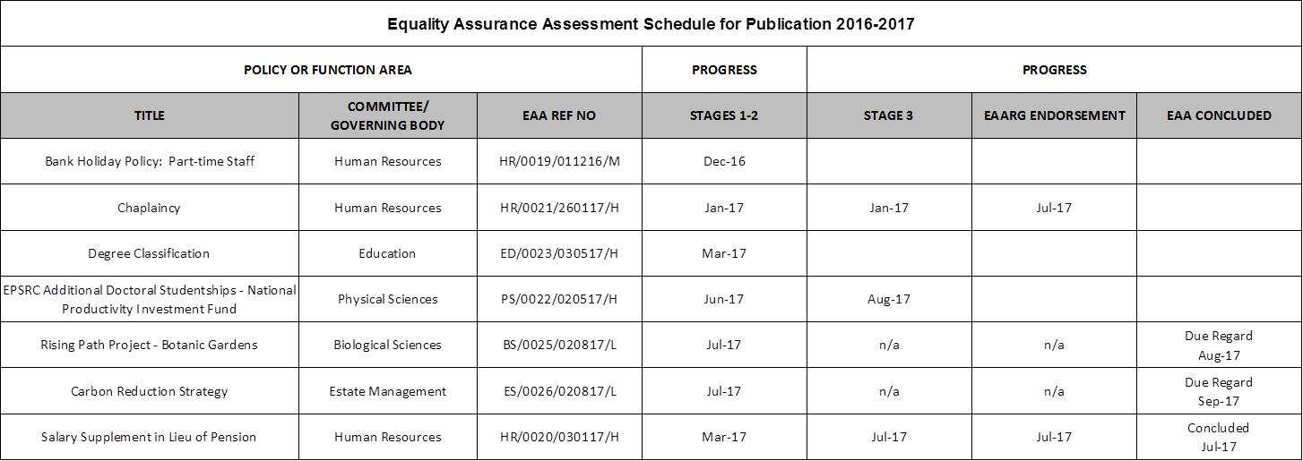

1. The University’s E&D Committee is chaired by the Pro-Vice Chancellor for Institutional and International Relations. Membership includes the Pro-Vice Chancellor for Education, University Equality Champions, two Heads of Schools, and representatives of a number of University bodies including Non-School Institutions, HR, student officers and staff diversity networks.
2. <http://www.equality.admin.cam.ac.uk/files/university_of_cambridge_equality_diversity_strategy_2016-2021_2.pdf>
3. <https://www.hr.admin.cam.ac.uk/people-strategy>
4. All Equal Pay Reviews and can be found on the HR Division website at: http://www.hr.admin.cam.ac.uk/pay-benefits/pay-and-reward/pay/equal-pay-reviews
5. http://www.ecu.ac.uk/equality-charters/athena-swan/
6. <https://www.cctl.cam.ac.uk/support-and-training/training-and-guidance>
7. [**http://www.educationalpolicy.admin.cam.ac.uk/files/cop_reasonable_adjustments.pdf**](http://www.educationalpolicy.admin.cam.ac.uk/files/cop_reasonable_adjustments.pdf)
8. <https://www.gov.uk/government/uploads/system/uploads/attachment_data/file/587221/Inclusive_Teaching_and_Learning_in_Higher_Education_as_a_route_to-excellence.pdf>
9. <http://www.space.admin.cam.ac.uk/>
10. [www.hr.admin.cam.ac.uk/pay-benefits/cambens-employee-benefits/my-family-care](http://www.hr.admin.cam.ac.uk/pay-benefits/cambens-employee-benefits/my-family-care)
11. [see](http://www.equality.admin.cam.ac.uk/files/information_report_2015-16_draft_-_final.pdf) section 1.3
12. <http://www.businessdisabilityforum.org.uk/>
13. <https://www.studentcomplaints.admin.cam.ac.uk/harassment-sexual-misconduct>
14. <http://www.equality.admin.cam.ac.uk/training-overview/understanding-unconscious-implicit-bias>
15. Note: May include any of appointed members, elected members and ex officio members
16. [**http://www.admin.cam.ac.uk/offices/education/reviews/**](http://www.admin.cam.ac.uk/offices/education/reviews/)
17. In line with a UK government directive the University now waives the application fee for any applicant who is a national of the OECD's Development Assistance Committee (DAC) [list of Overseas Development Aid](https://www.graduate.study.cam.ac.uk/download/application-fee-waiver-eligibility) (ODA) recipients, groups 1 (Least Developed Countries) and 2 (Other Low Income Countries) only. This has led to a significant increase in applications for graduate study from these countries. In addition for applications from all other countries, including the UK, there was also an increase of 30% in applications due to an increased demand for postgraduate education.
18. <http://www.disability.admin.cam.ac.uk>

   
19. Cambridge Human Resources Information System
20. http://www.admin.cam.ac.uk/univ/so/2009/statute_d.html#heading2-1
21. Please note: Clinical Professors, Readers, University Lecturers, Senior Lecturers, Research Associates and Senior Research Associates have been mapped to the University’s grading system for the purposes of this information analysis.
22. http://www.hr.admin.cam.ac.uk/pay-benefits/salary-scales
23. http://www.hesa.ac.uk/index.php
24. For details on all HESA staff categories go to http://www.hesa.ac.uk/dox/datacoll/C11025/11025.pdf?v=d41d8cd98f00b204e9800998ecf8427e